#### Map View, Layer list & Right-Nav

#### [Echoes - Land Management](https://echoes-platform.eu/app/main/map-view)

54 Steps

Go to <https://echoes-platform.eu/app/main/map-view>

1 - Map View Section

Click on the 'Map View' icon to enter the map view section.

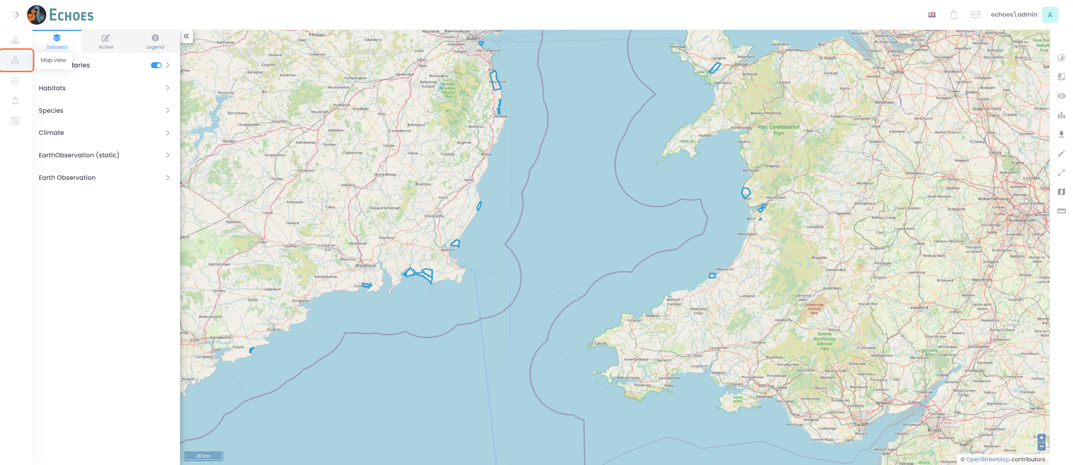

2 - View Site Boundaries

Clicking on the 'Site Boundaries' section will open a list of your sites.

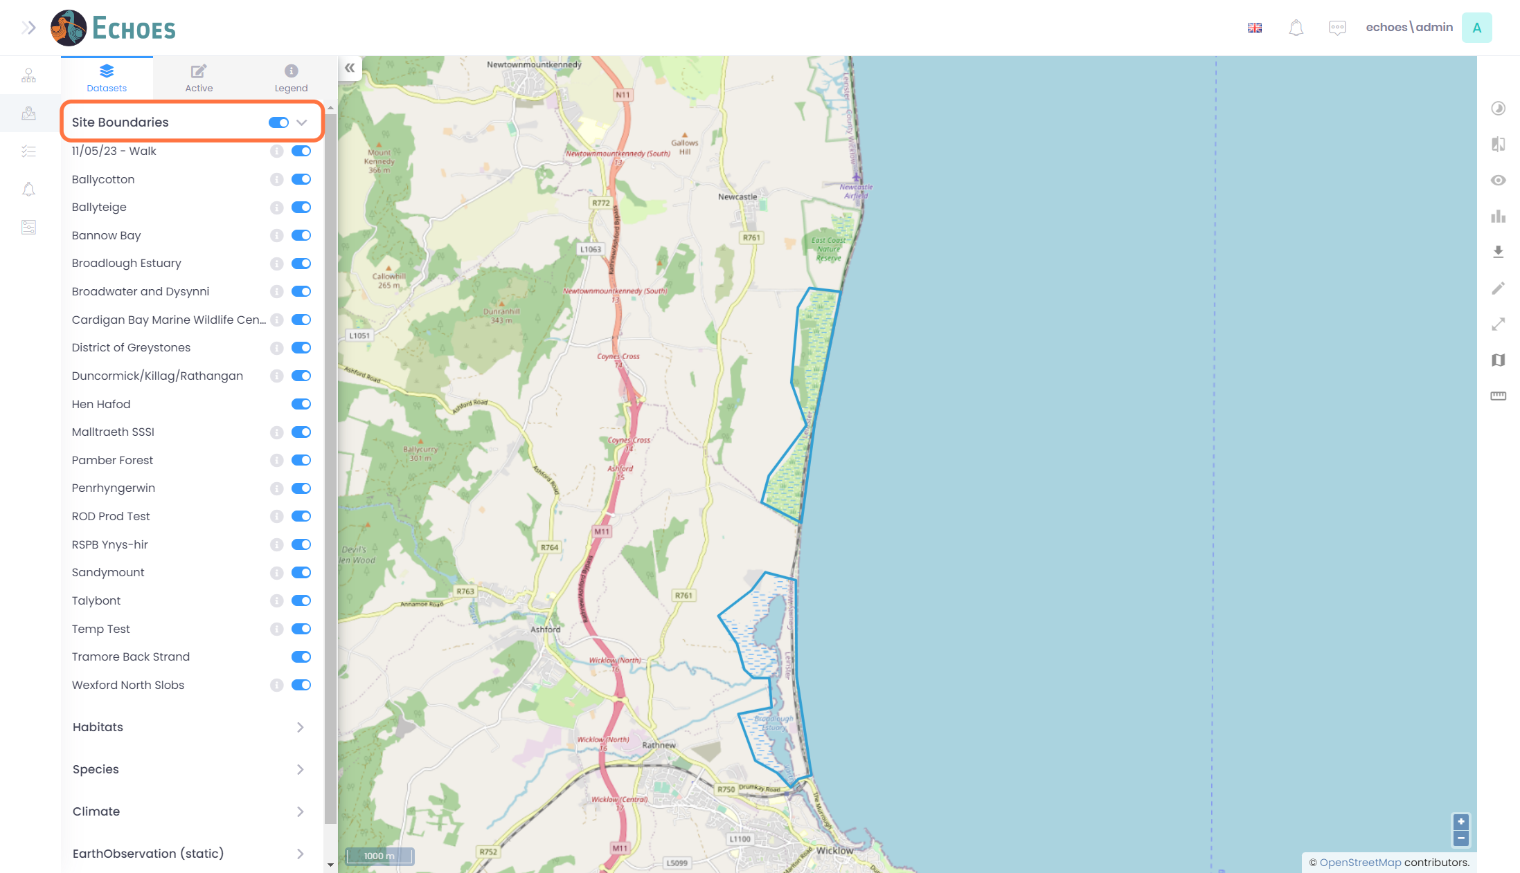

3 - Toggling Sites Boundaries on and off

Clicking on the toggle icon next to one of the sites will turn off the boundary on the map view

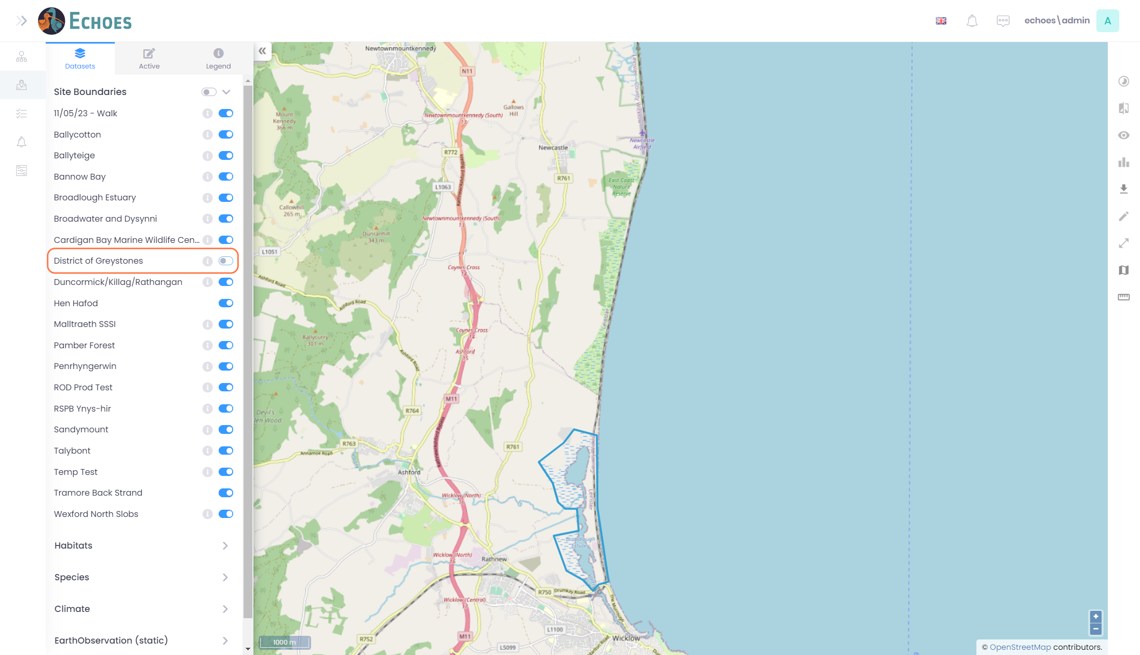

4 - Viewing the Layers Information (1/2)

As well as just hovering your mouse over the layer, you will see the 'i' icon.

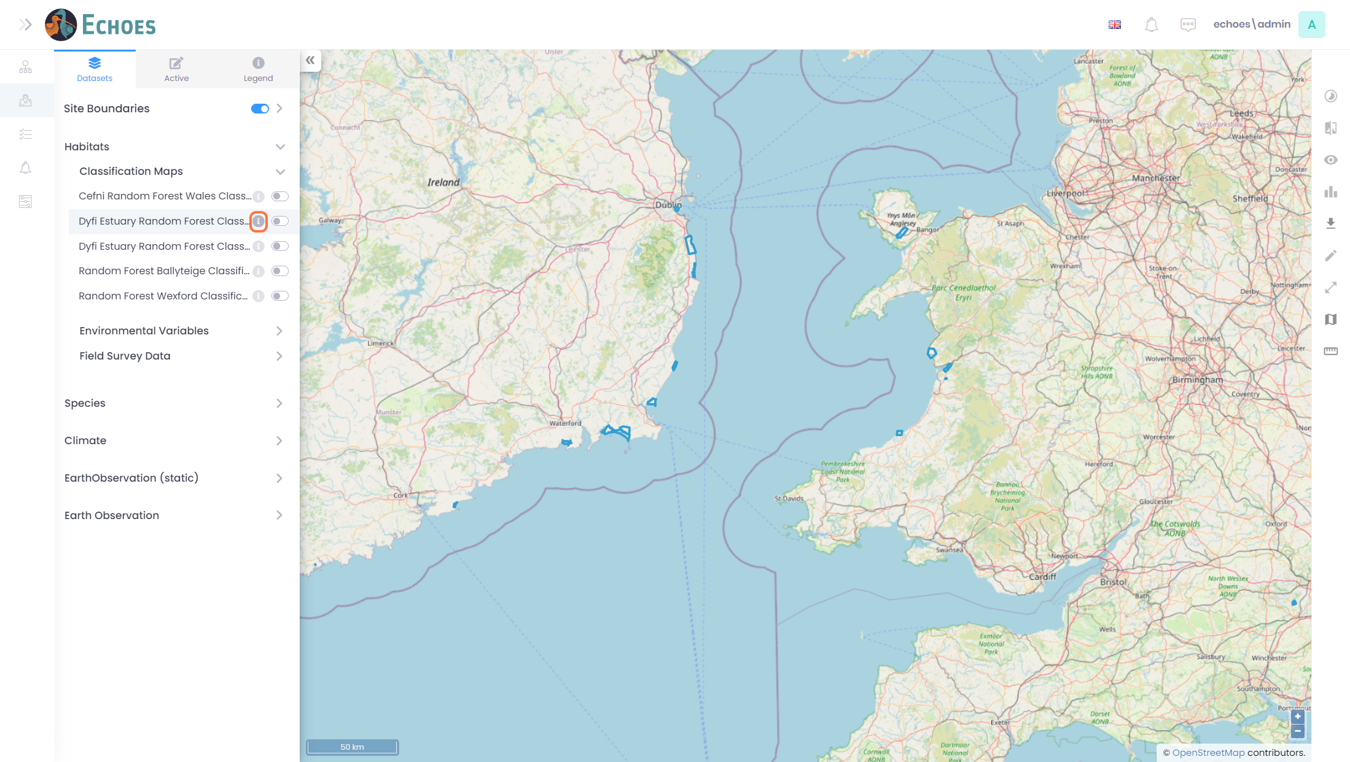

5 - Viewing the Layers Information (2/2)

Clicking on the icon will open a the 'i' icon will open a pop up like below. This will give you a little more information about the layer and some will have links to locations of the available date.

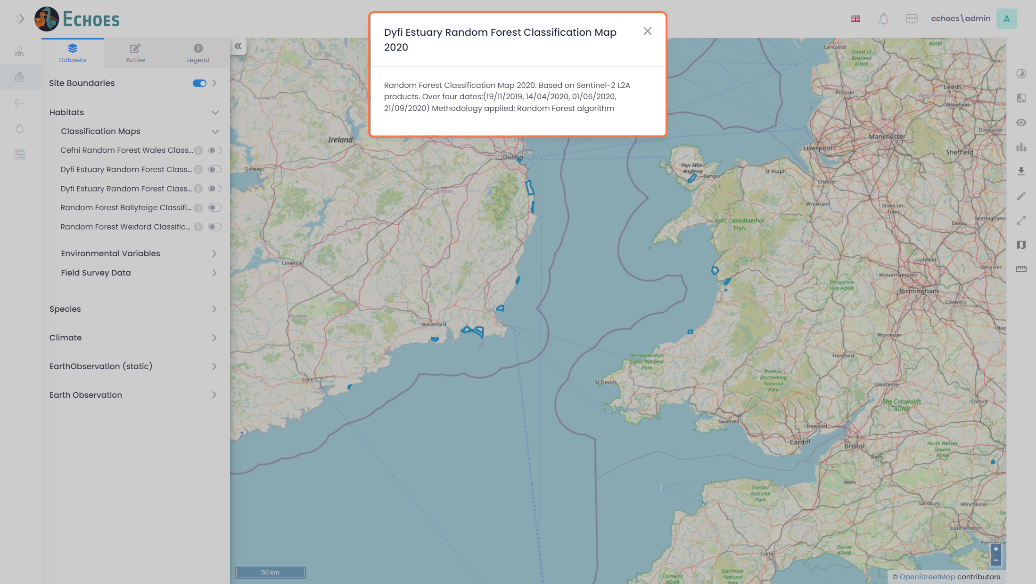

6 - Toggle on a Layer (1/2)

Clicking on the toggle icon next to the layer will turn the layer on to view on the map. For this example, I am using the layer 'Dyfi Estuary Random Forest Classification Map 2020'

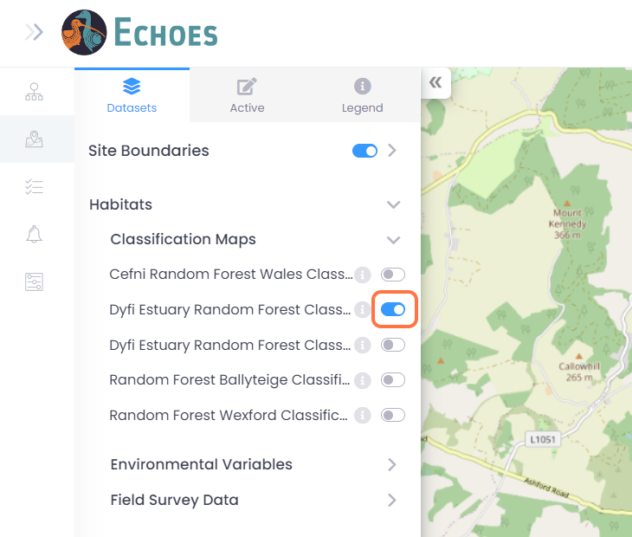

7 - Toggle on a Layer (2/2)

The layer will now be visible on the map. You can click any where on the layer to show a pop up with information around that point based on a legend. The example below shows that that point is 'Marshy grassland Juncus dominated'

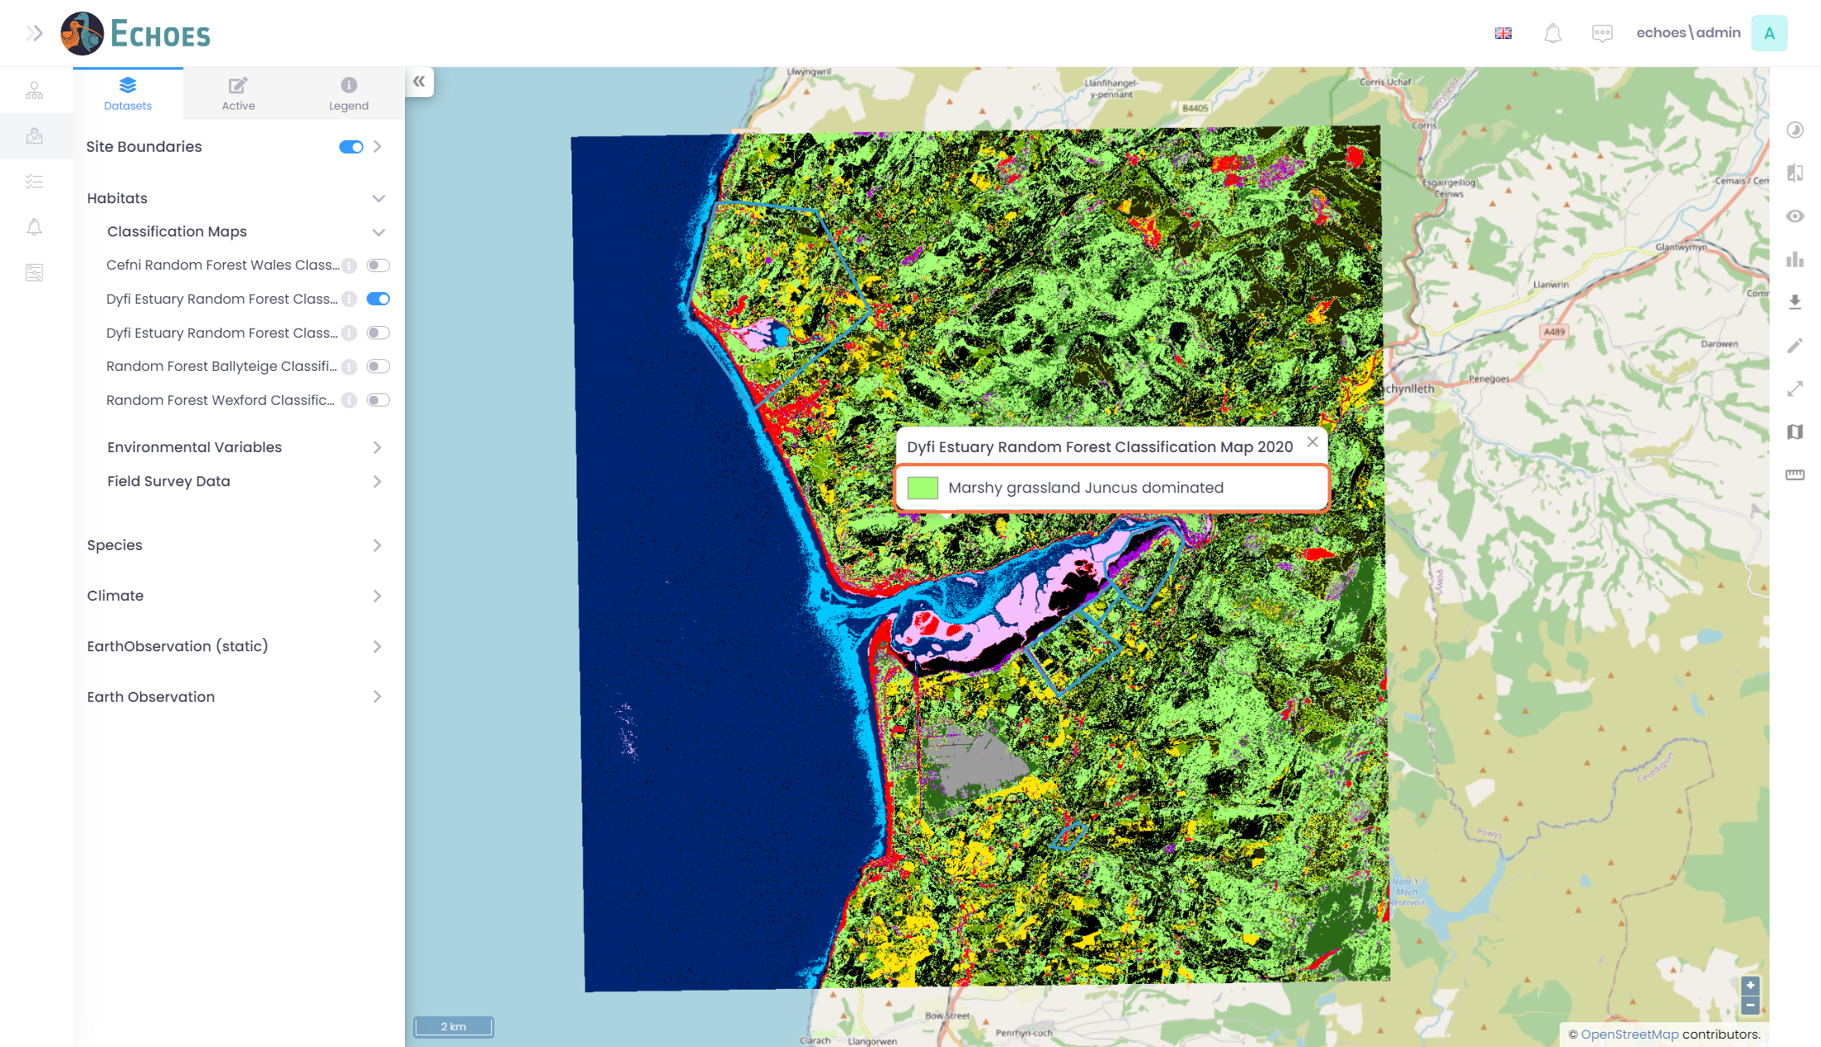

8 - Viewing the Active Layers tab

There is a tab available called 'Active'. This will show you all the layers that are toggled on in 1 place, with the ability to re-order, change opacity and zoom to.

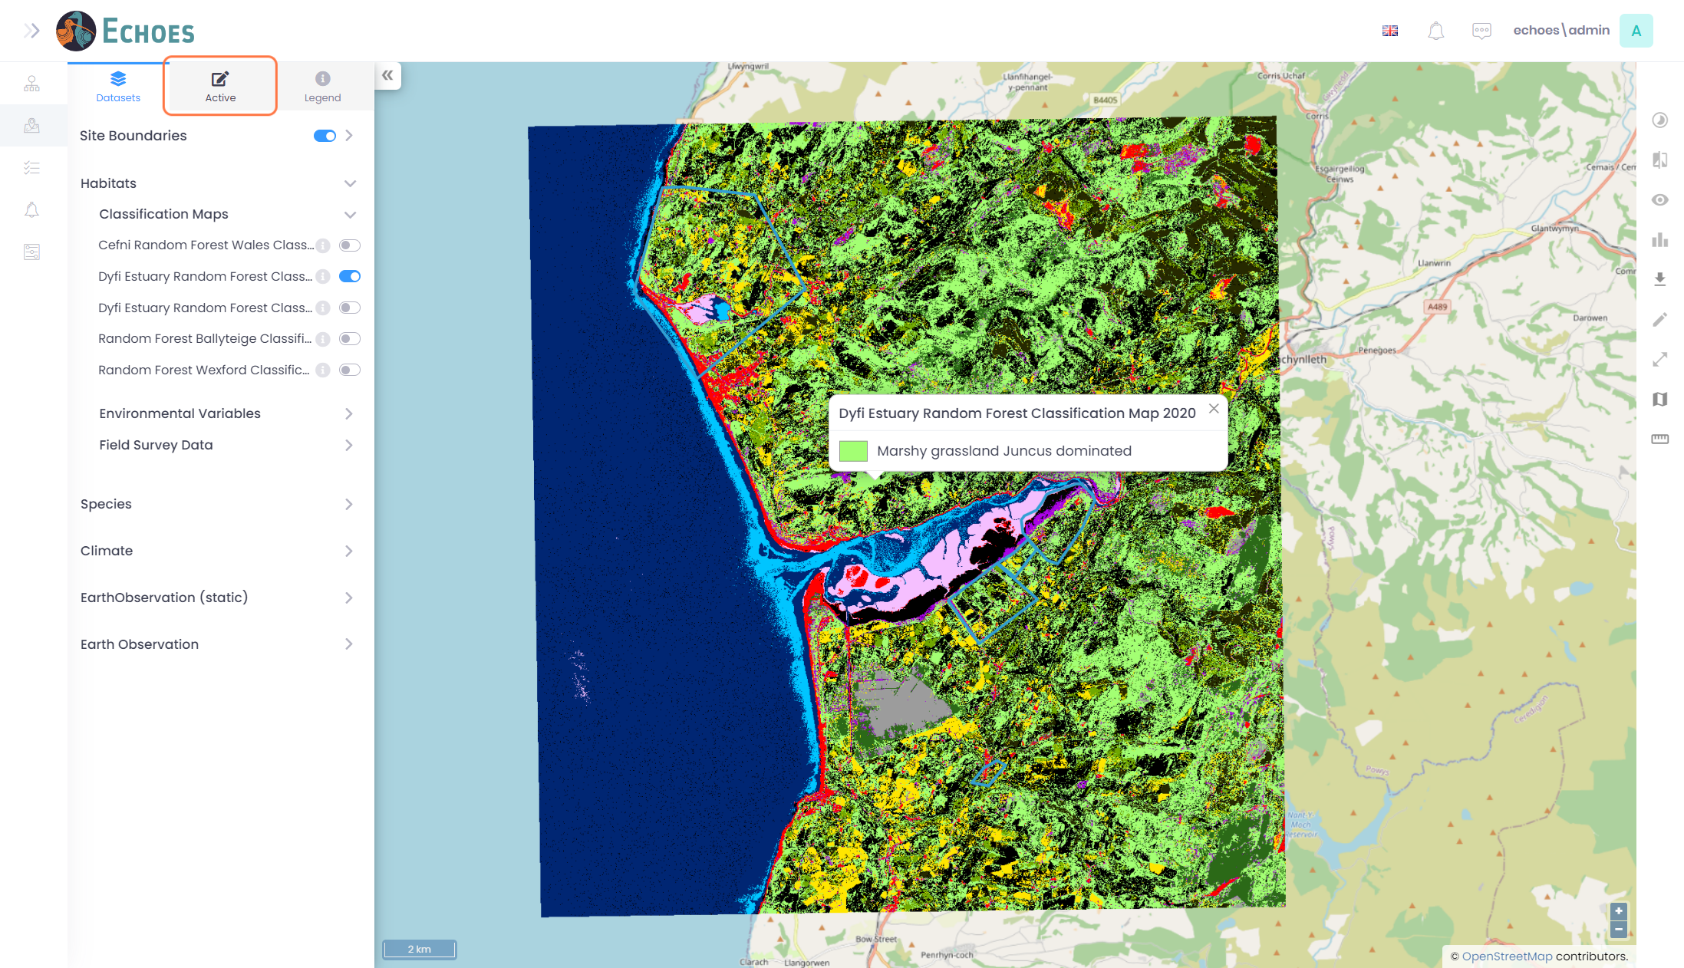

9 - Active Tab

Within the Active tab you have multiple tools you can use that will be explained in the next x Steps

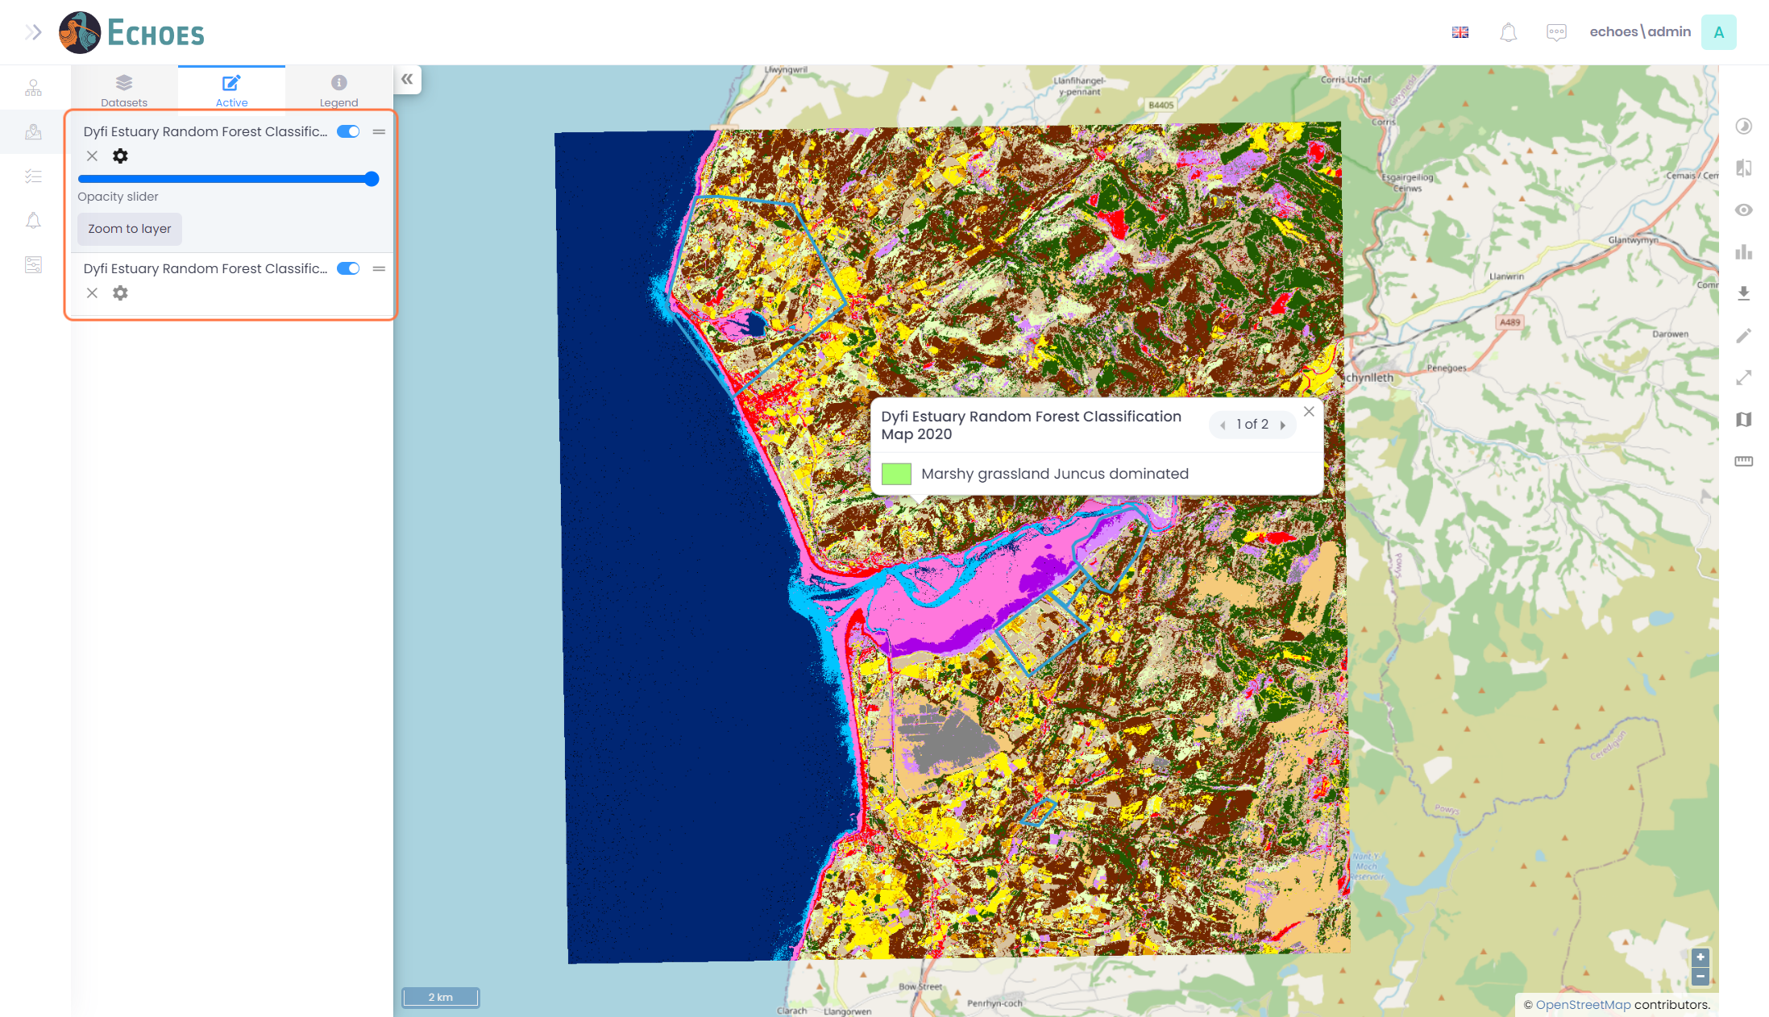

10 - Temporary Toggle layers On/Off

Clicking the toggle icon on the layer will temporarily disable a layer.

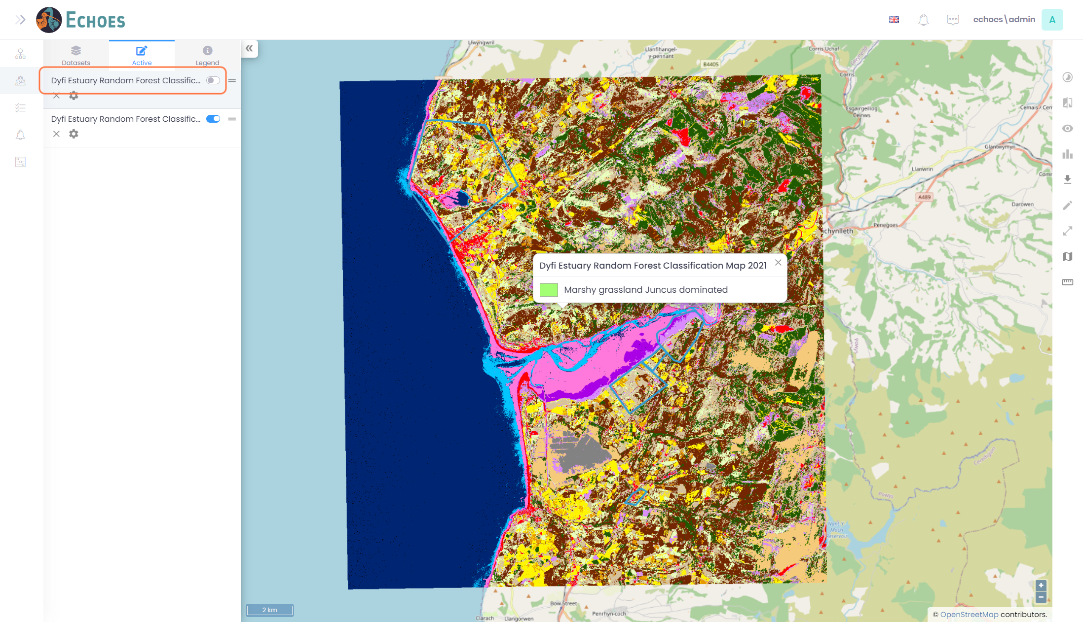

11 - Re-ordering of Layers

Clicking and holding on the icon below, then dragging the layer up or down will re-order the layers on the map view.

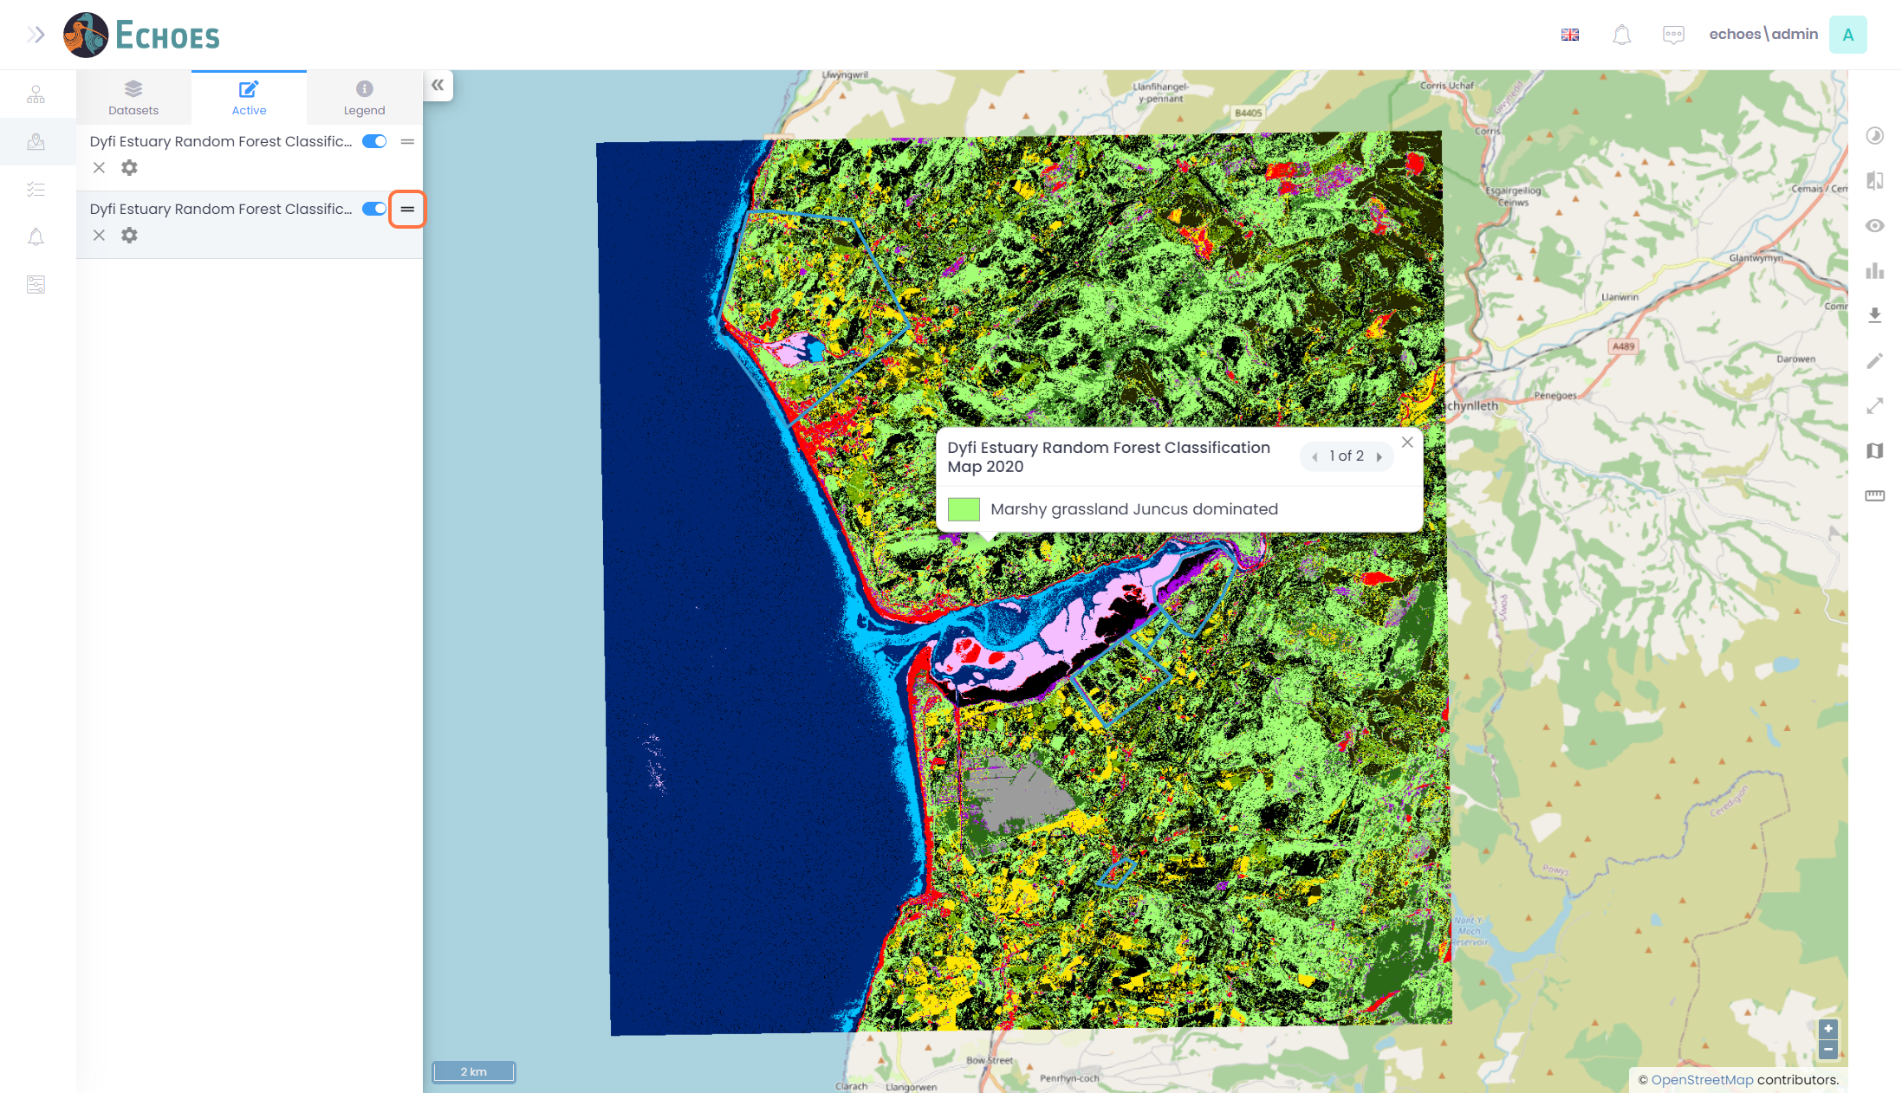

12 - More Tools

Clicking on the 'Cog' icon will open more tools you can use.

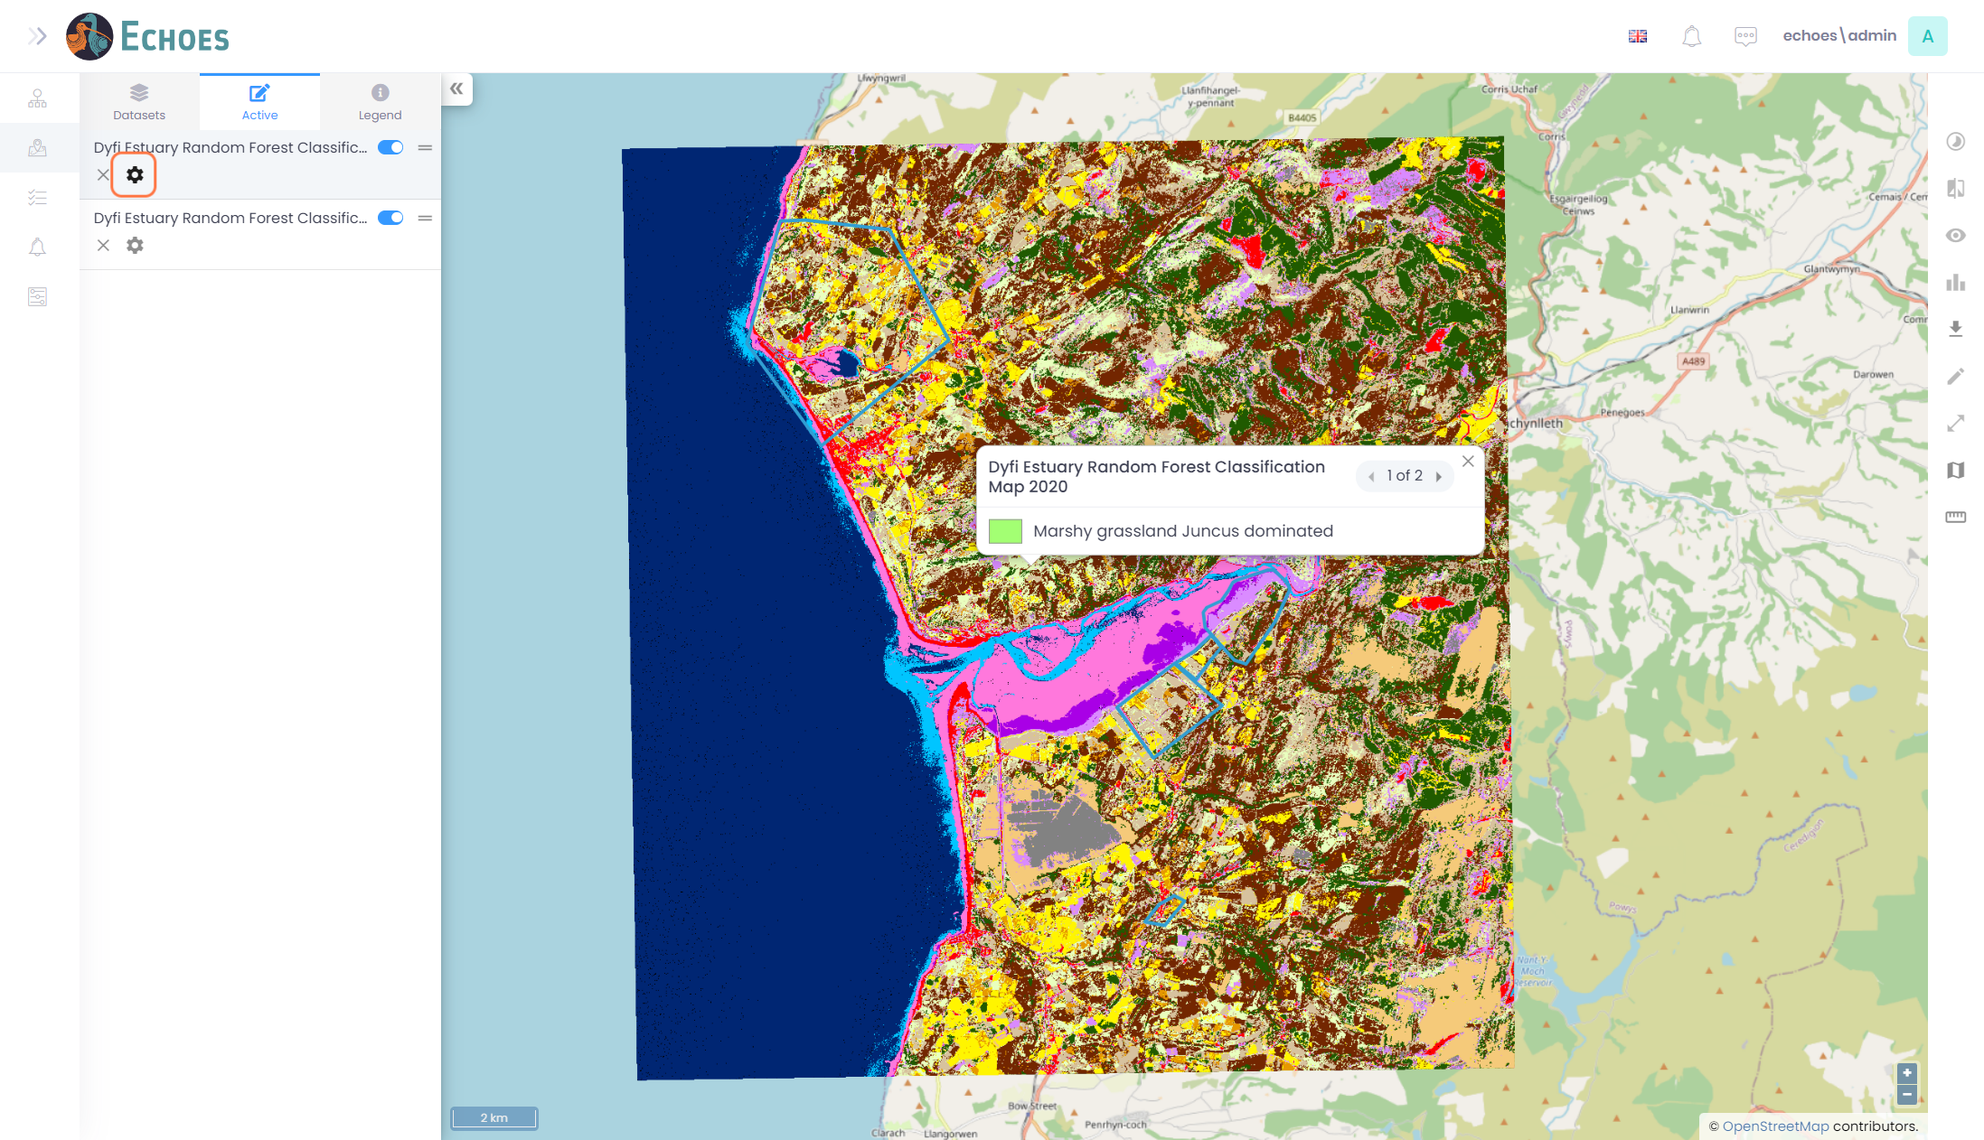

13 - Change Opacity & Zoom to Layer tools

* Opacity Slider - A slider is now available for you to turn the opacity of the layer down or up. Turning the opacity down will show the layer below a little more the further down you go.
* Zoom to layer - If you click the 'Zoom to Layer' the map extent will move and zoom to that layer.

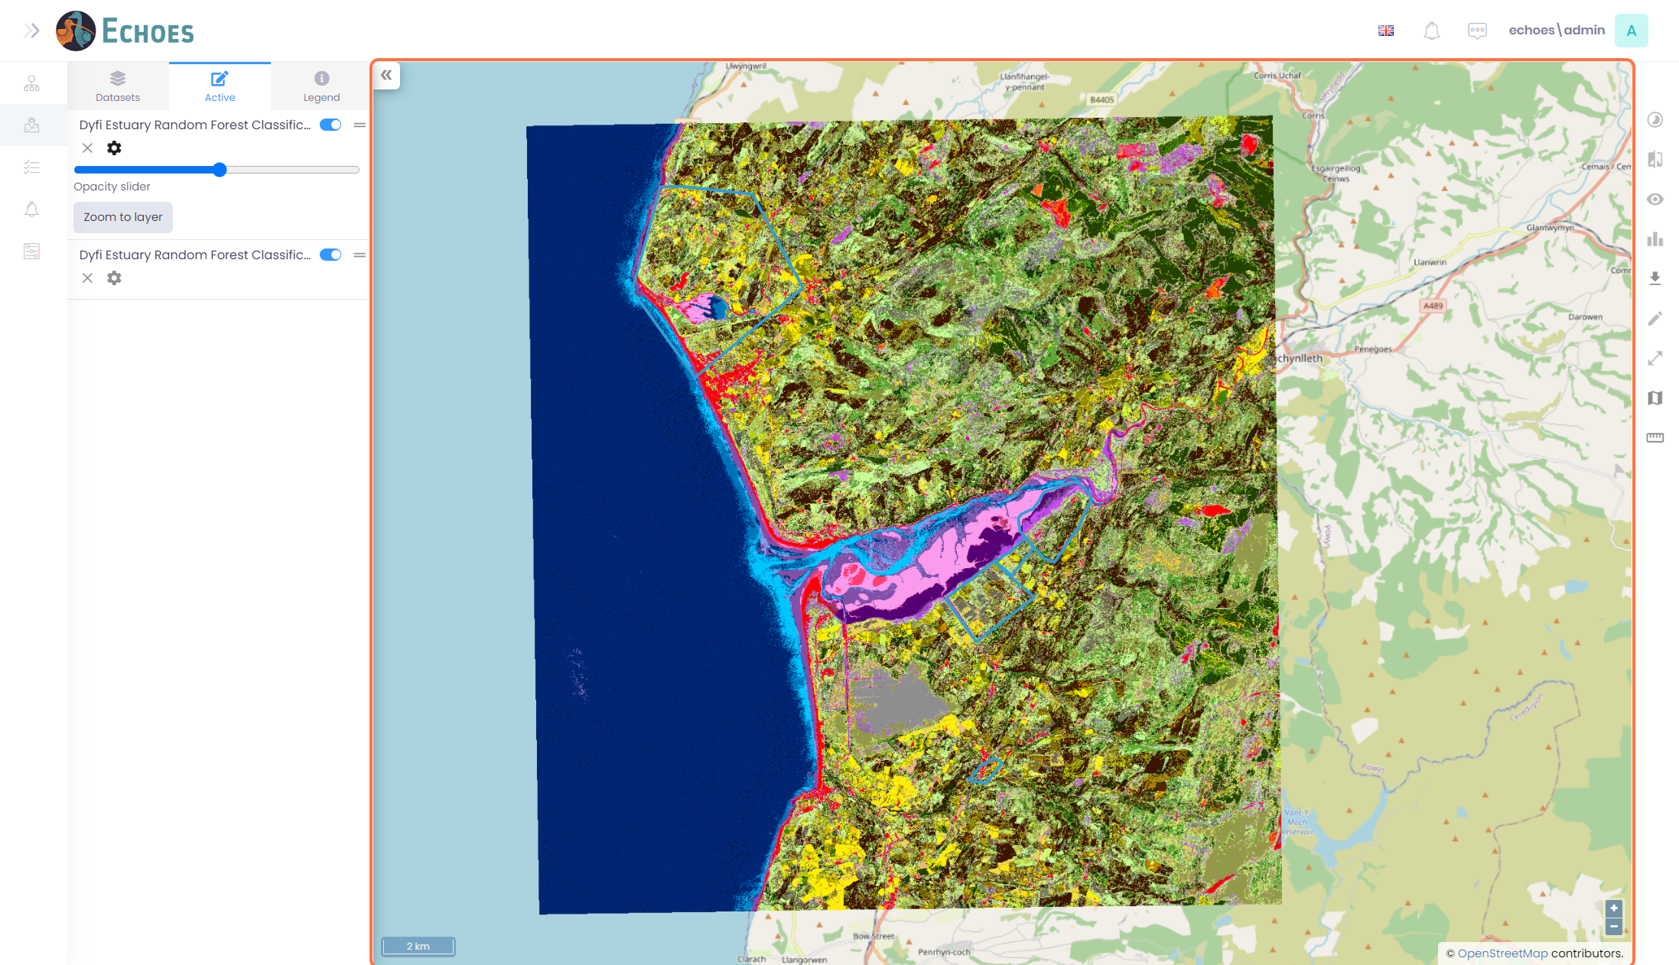

14 - Click on Legend

There is a tab available called 'Legend'. This will show you all the symbology for all the layers that are currently turned on.

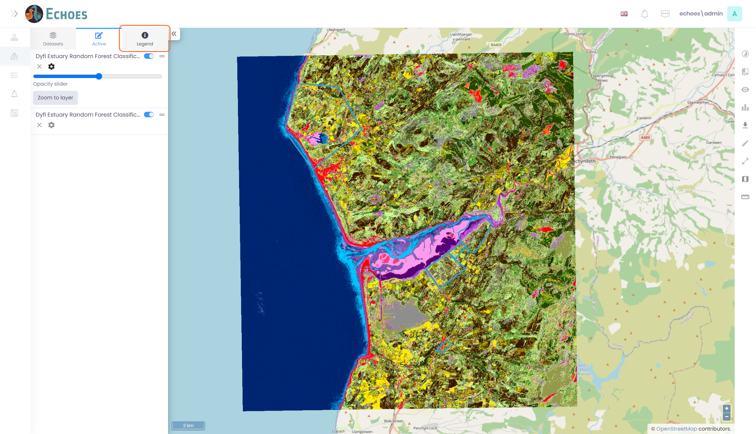

15 - Legend & Map View Symbology

The symbology in the Legend tab is reflected by the map pop-ups when you click a point on the map.

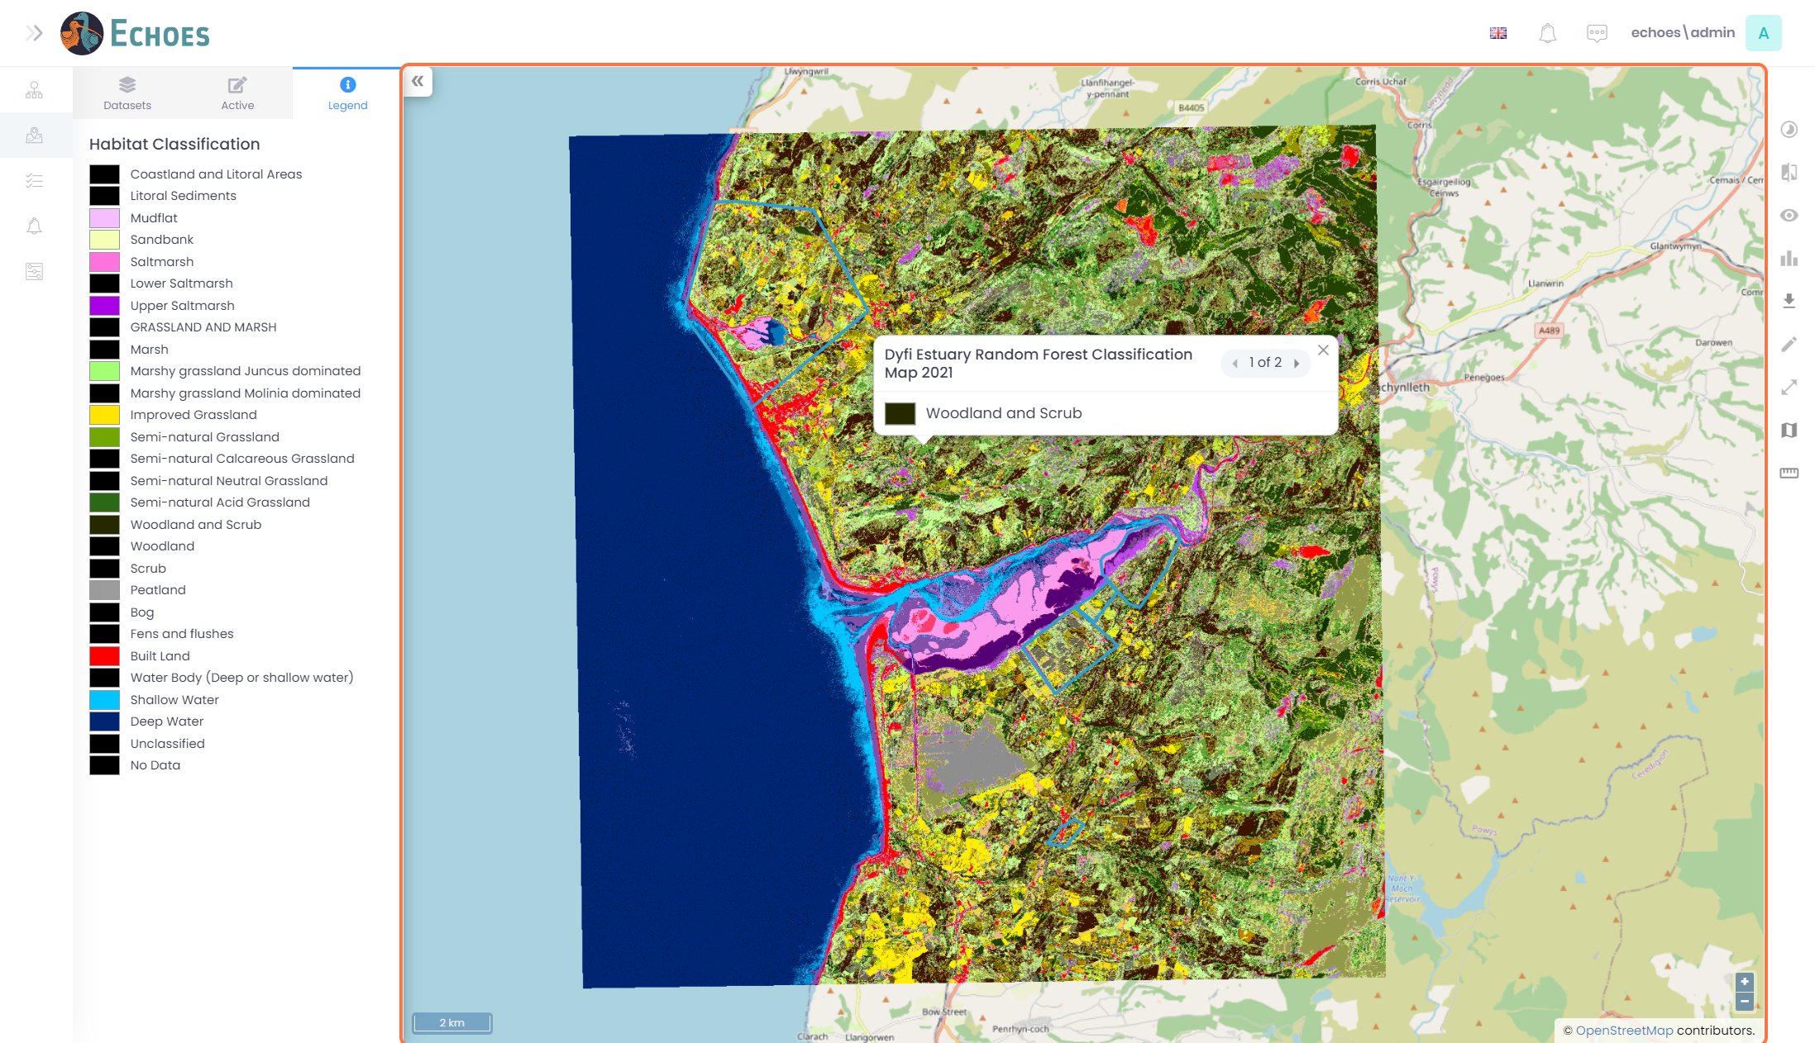

16 - Toggling through Layers Pop-up (1/2)

When you click on the map and the pop-up appears, you will see the corresponding information about that layer. If you have more than 1 layer currently active, you will see a '1 of x' with arrows left & right for navigation.

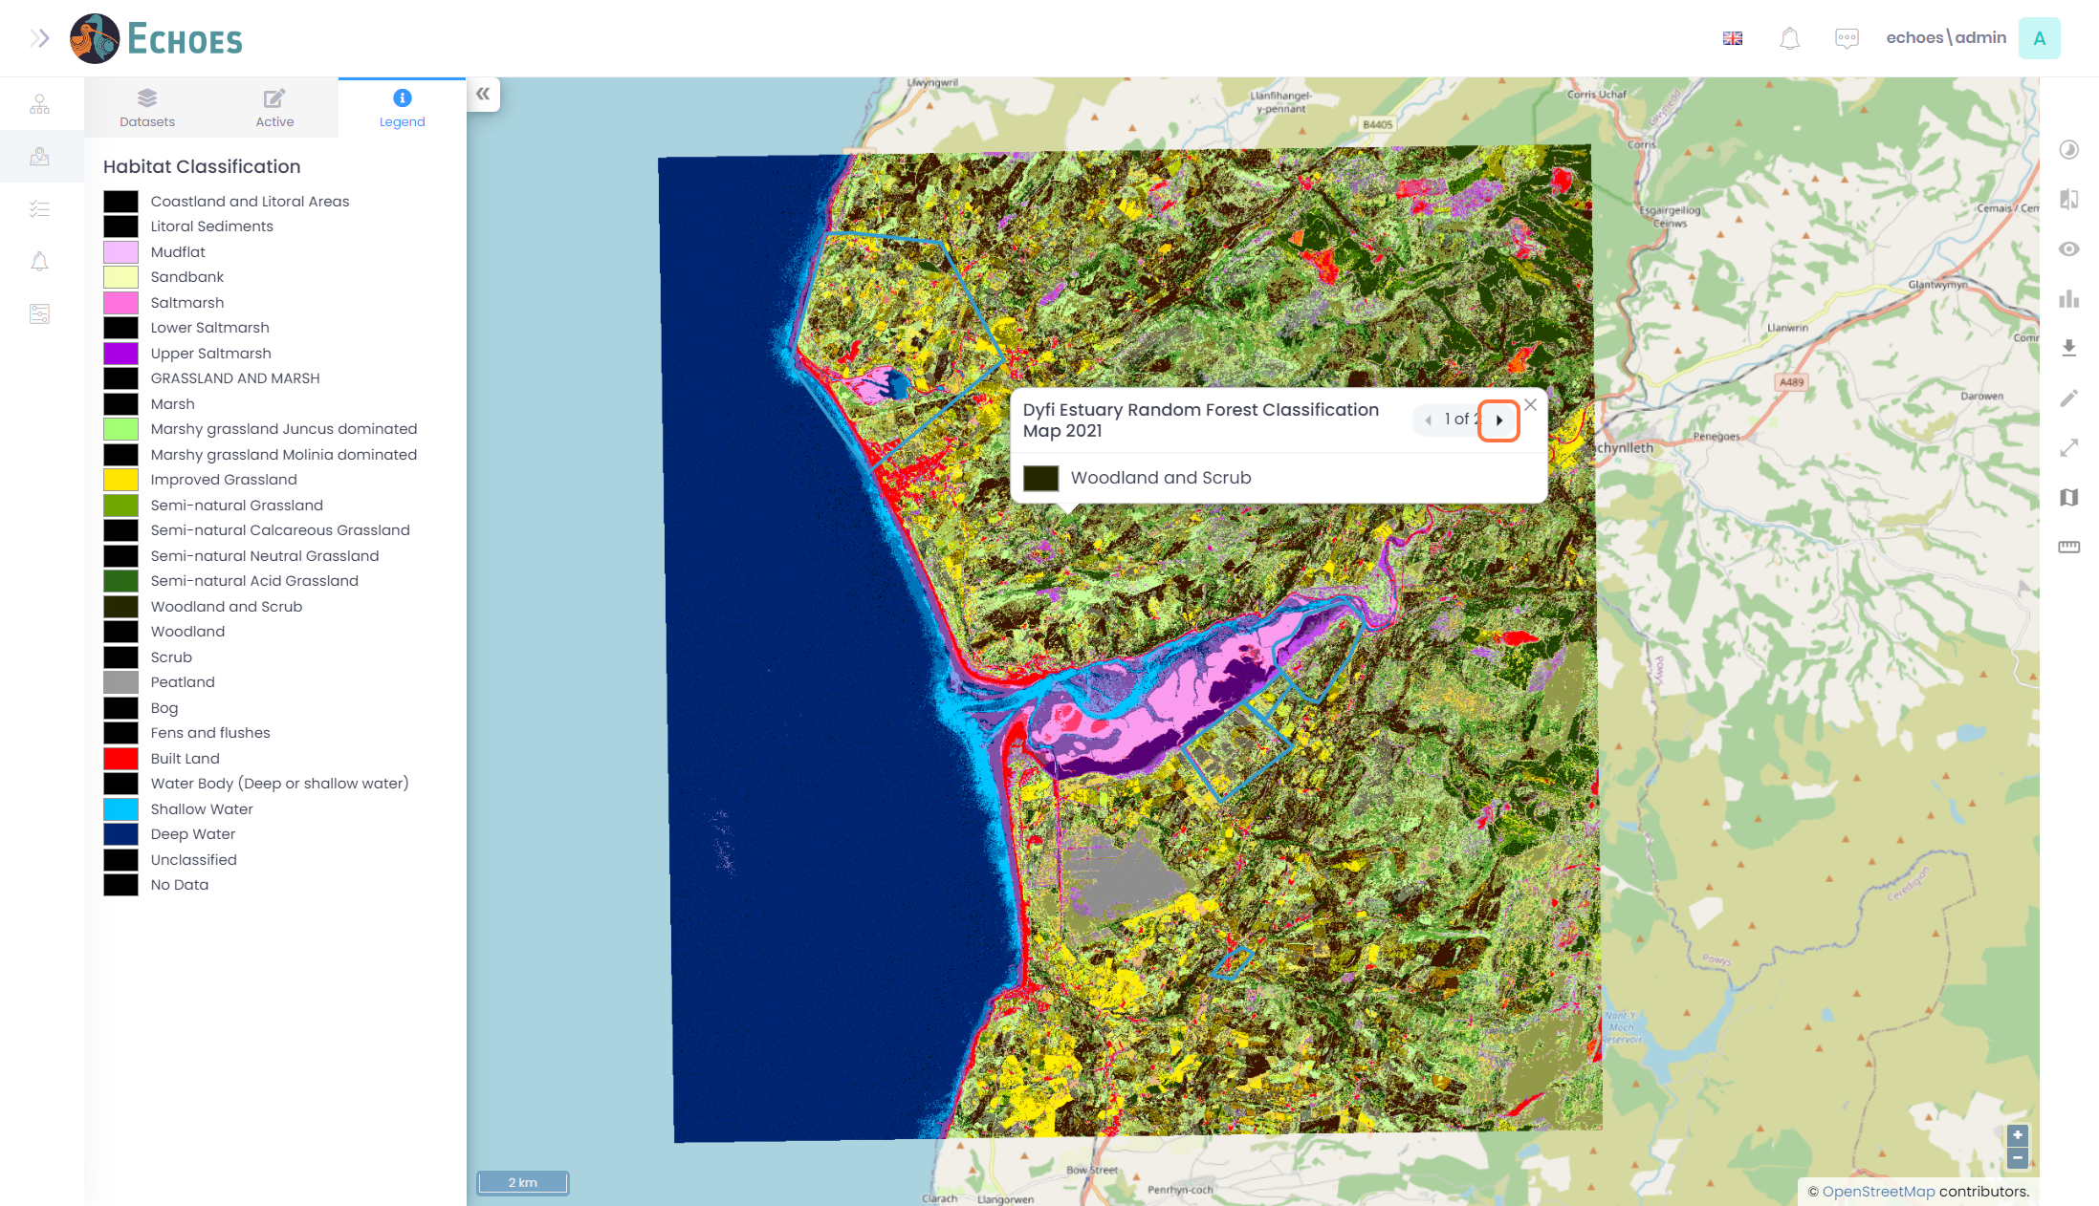

17 - Toggling through Layers Pop-up (2/2)

When you click on the arrow, you will get the information for the next layer you have toggled on.

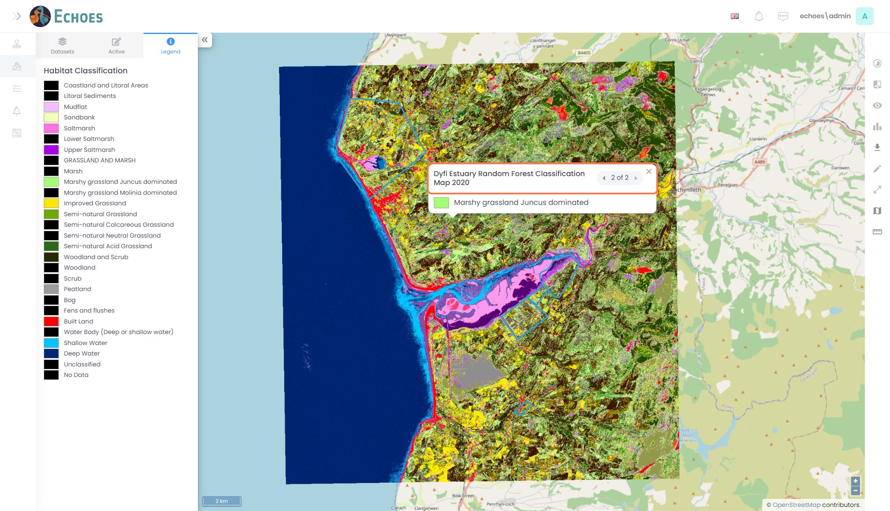

18 - Tracking Data

When you turn on any of the tracking data layers you will then see them show up individually on the map.

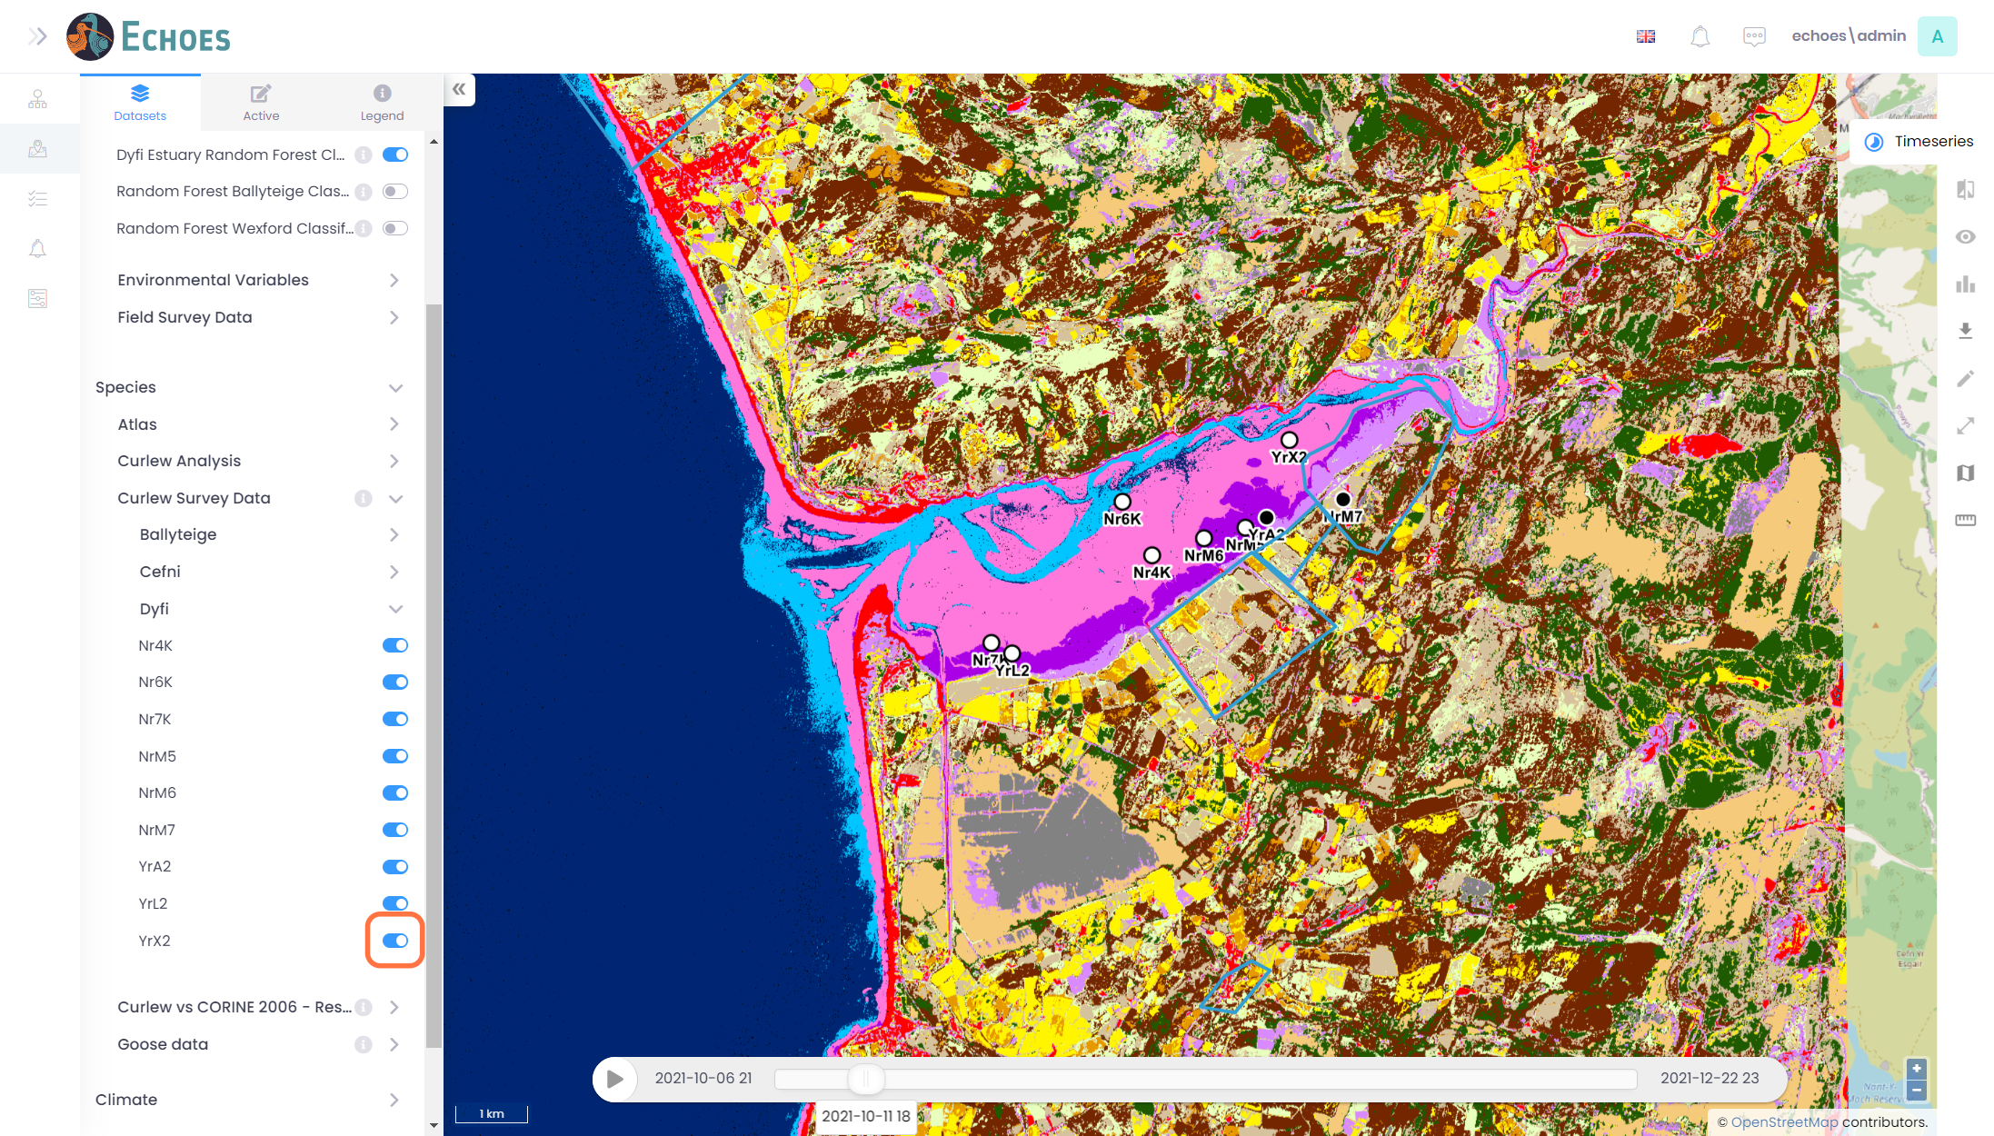

19 - Tracking Data Time Series (1/4)

When you toggle on the layers you will see that there is a Time Slider at the bottom with a start and end date for the layers.

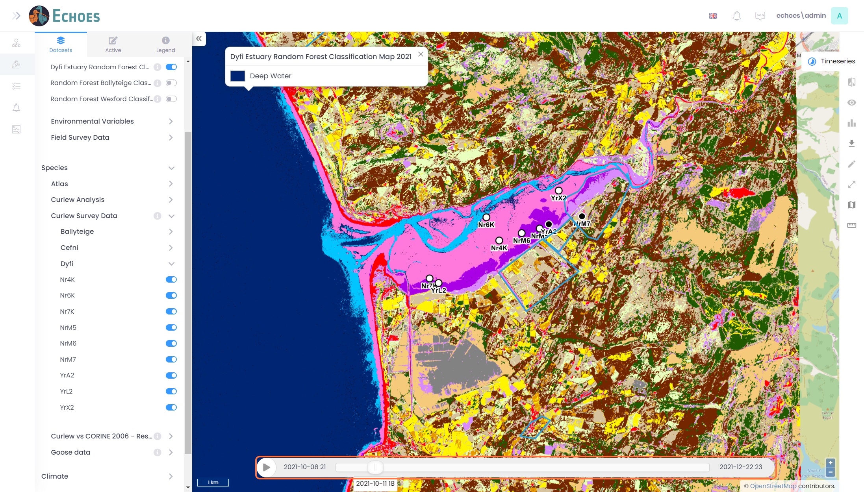

20 - Tracking Data Time Series (2/4)

You can click the play icon to allow the time series to play through all the tracking data images. You will see the changes on the map view.

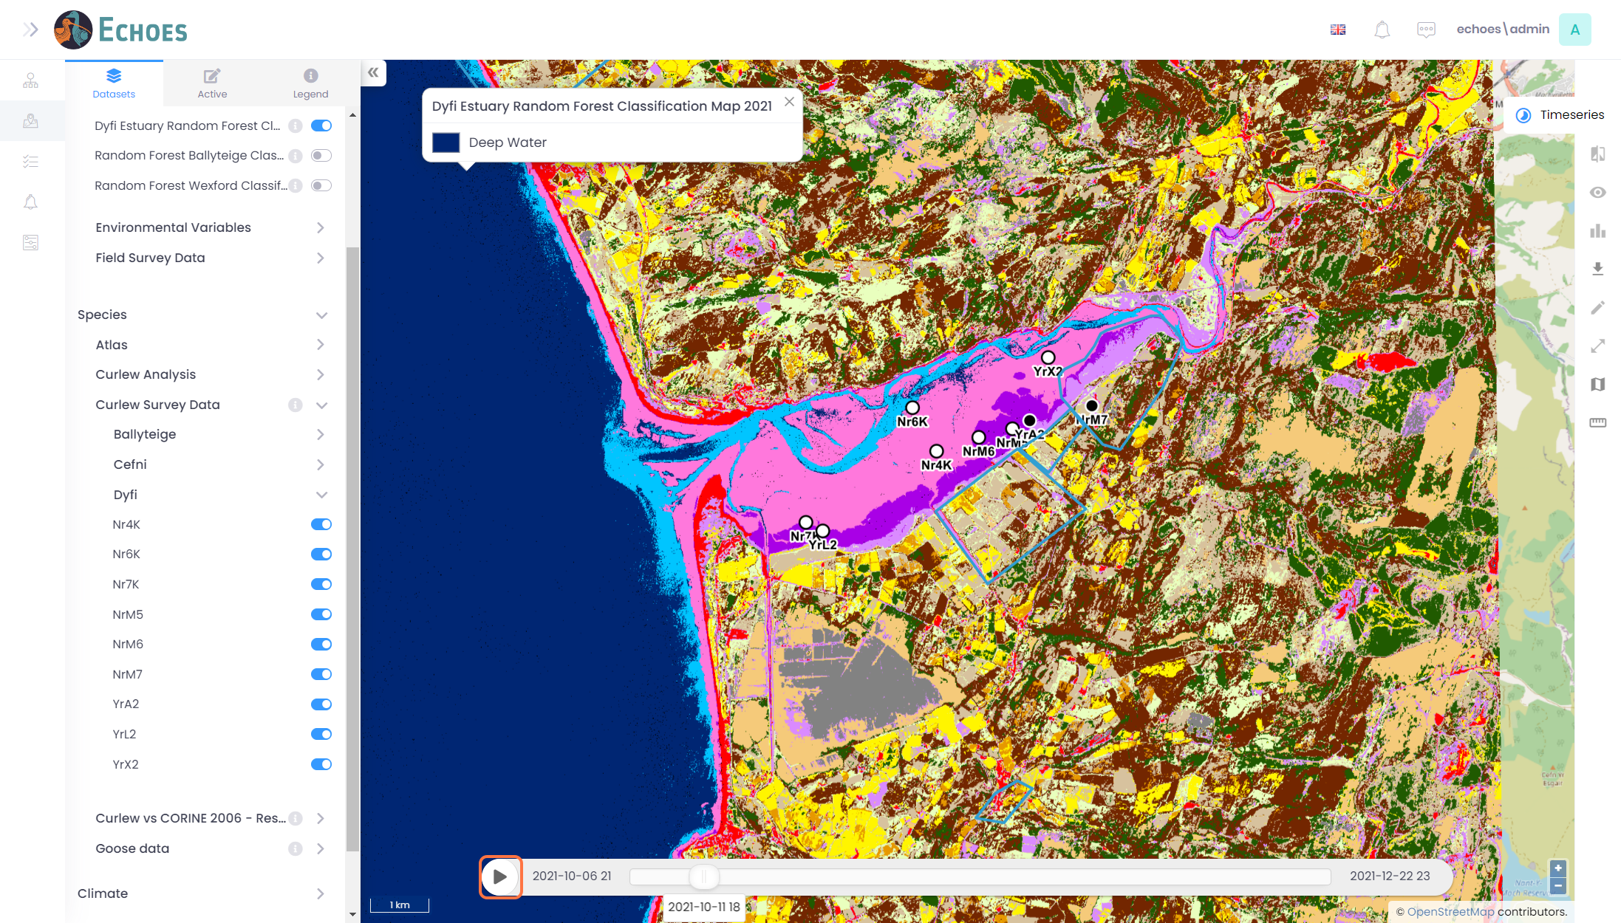

21 - Tracking Data Time Series (3/4)

You can slider to time slider manually to a time your want to see.

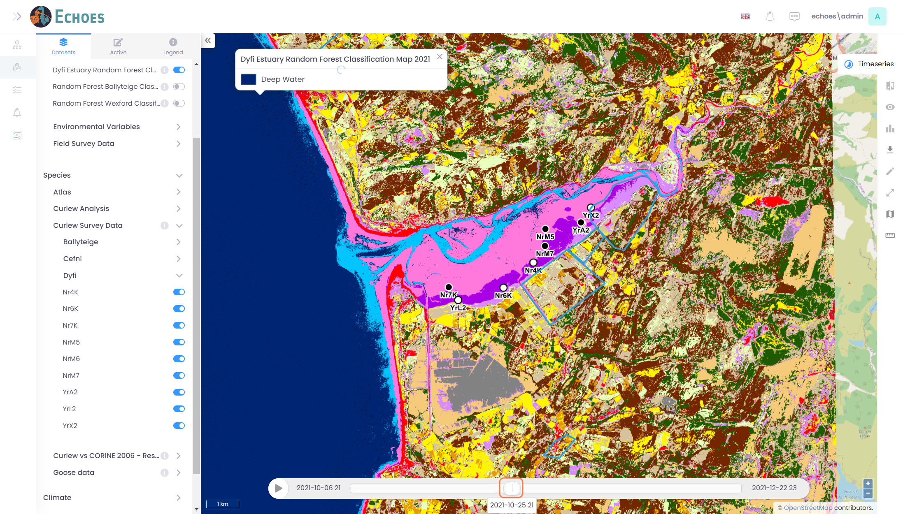

22 - Tracking Data Time Series (4/4)

You can see that the images for the tracking data have now moved.

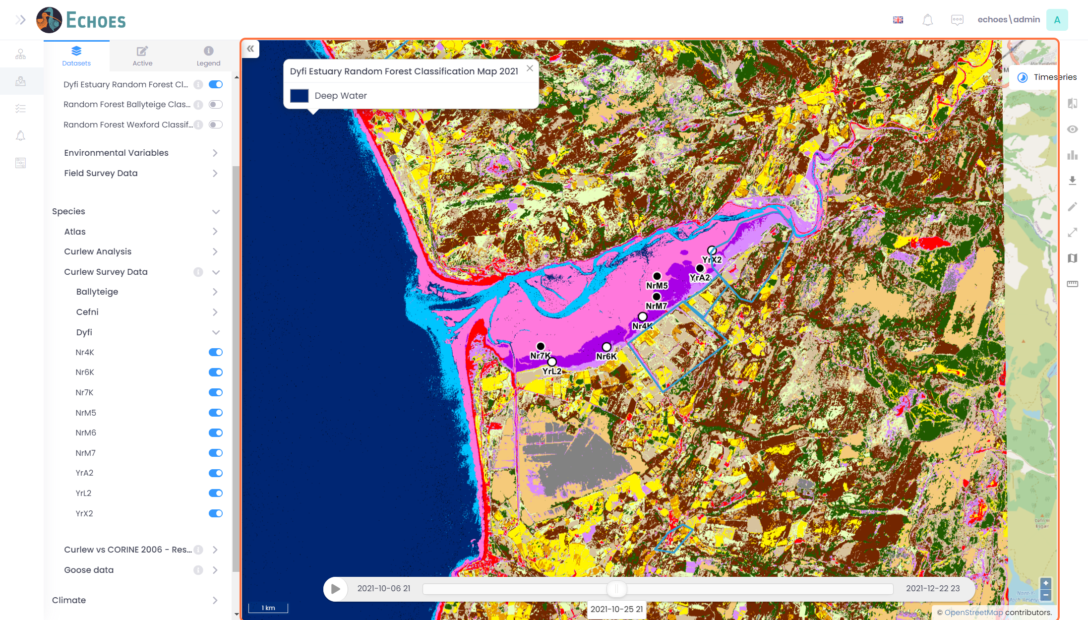

23 - Tracking Data Information (1/2)

You can click on the tracking data points to get more information about that particular point/ bird.

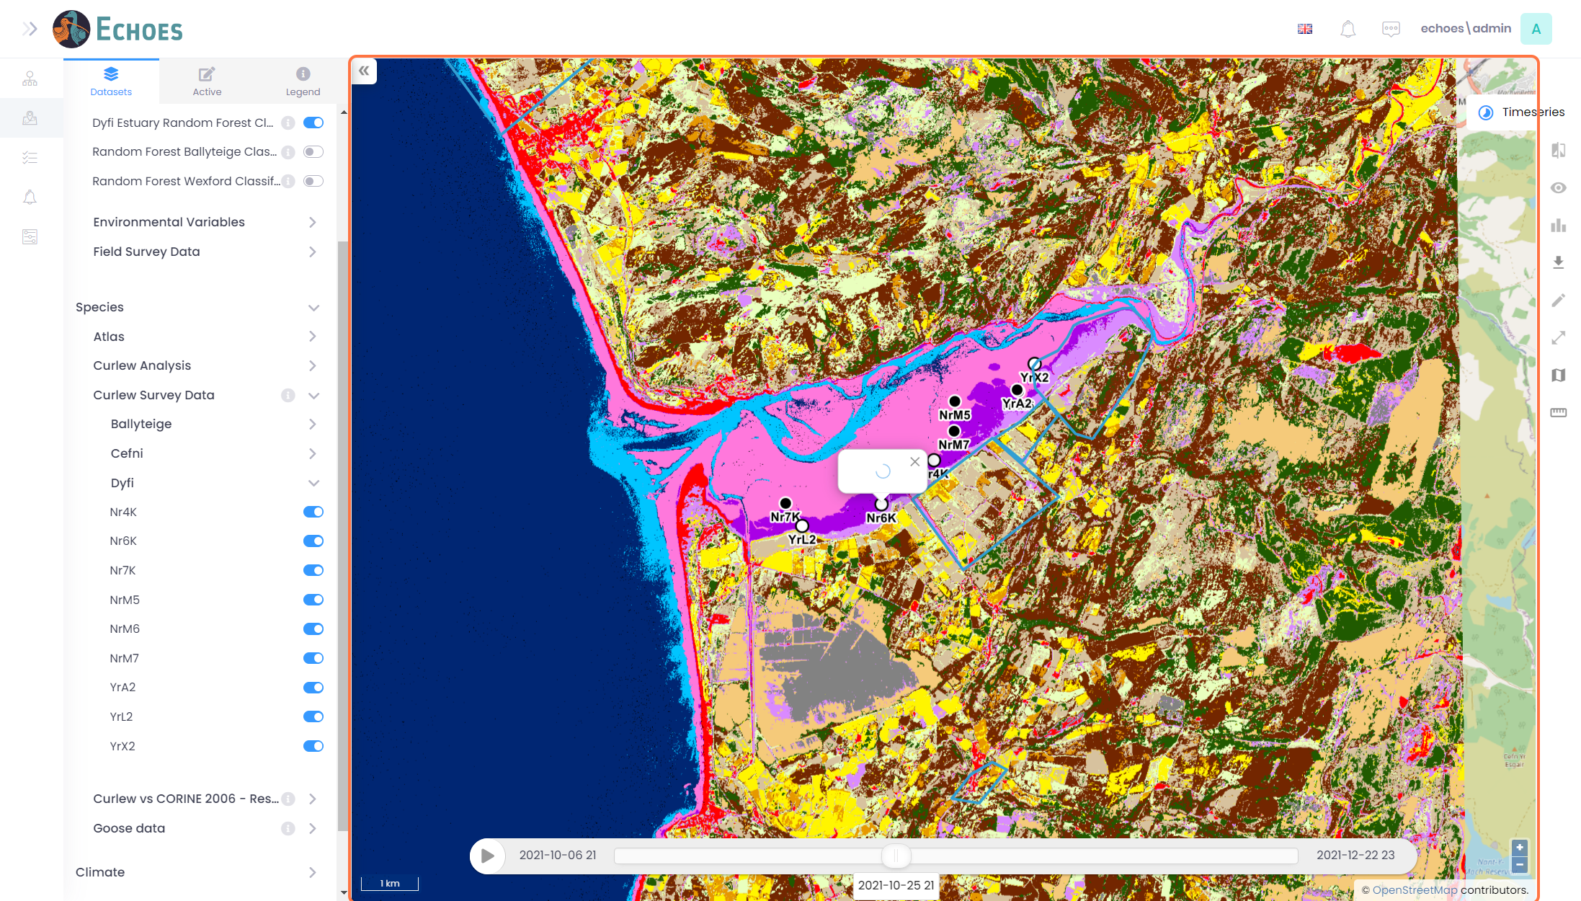

24 - Tracking Data Information (2/2)

The pop-up will now show the information about the point/bird similar to below.

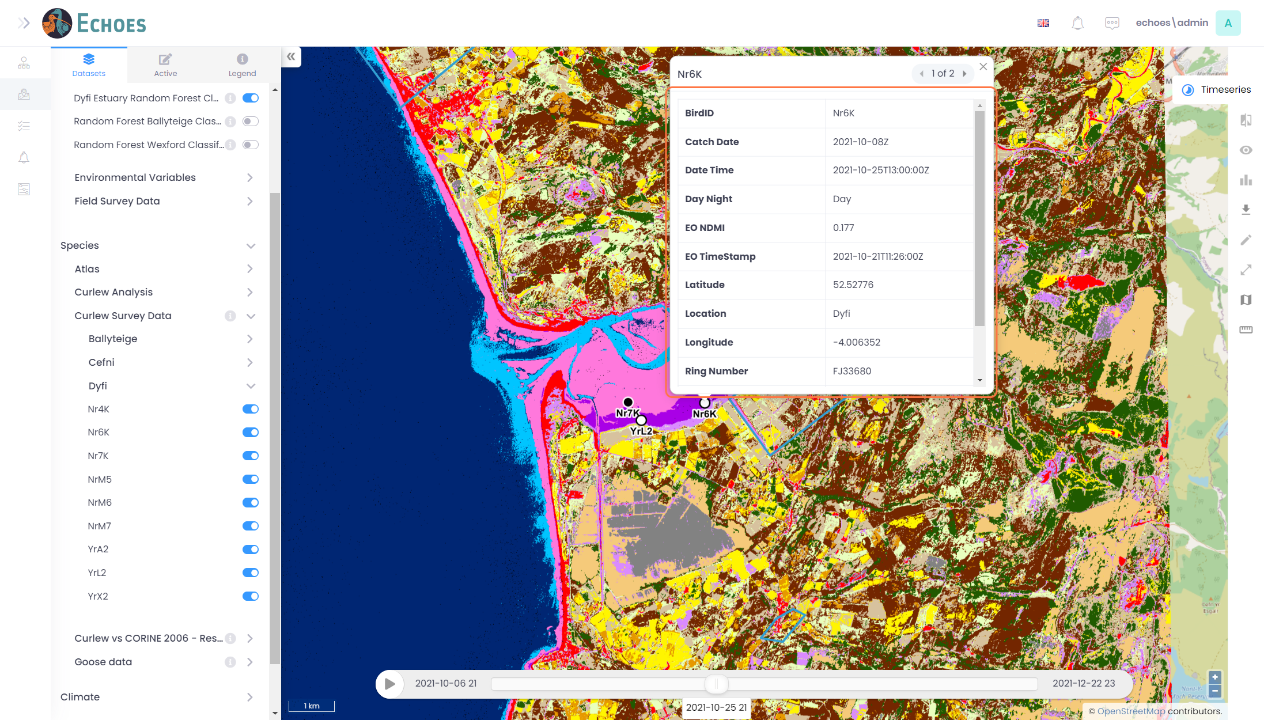

25 - Toggle on Climate Layers

Click on the toggle icon for the layer you want to see. This example is Mean air temperature - (RCP8.5)

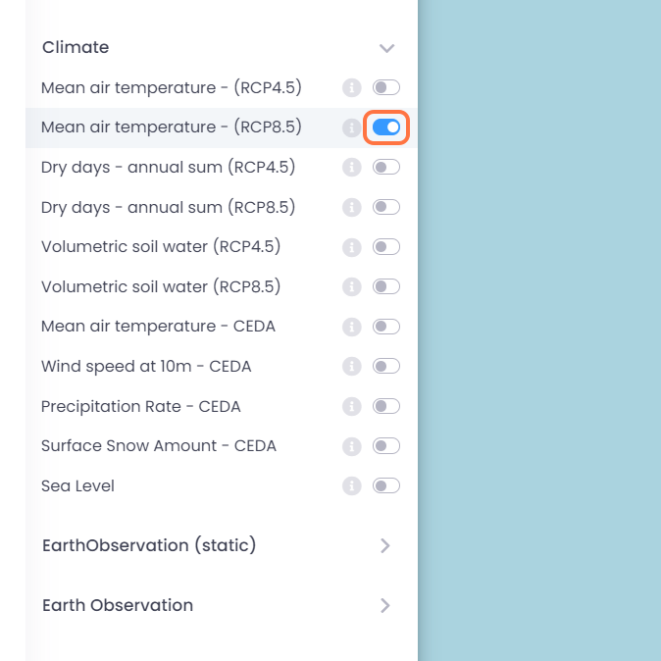

26 - Climate Layer Information

You can see the information for the climate data of a point by clicking on the map.

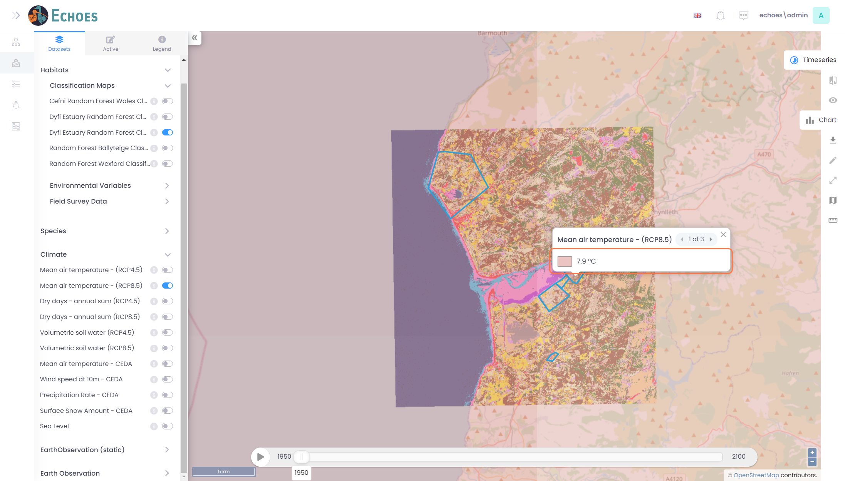

27 - Time Slider for Climate Data

When you toggle on a Climate layer you will see the time series slider.

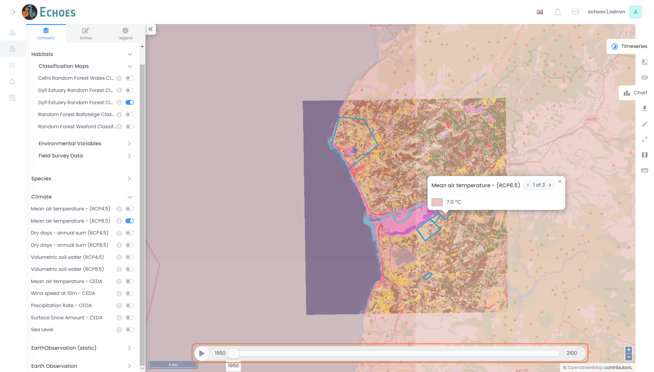

28 - Changing the Date

You can either click on the play icon for the slider to play itself, or you can slide the time along yourself. You will see the data in the pop-up change for that new selected time.

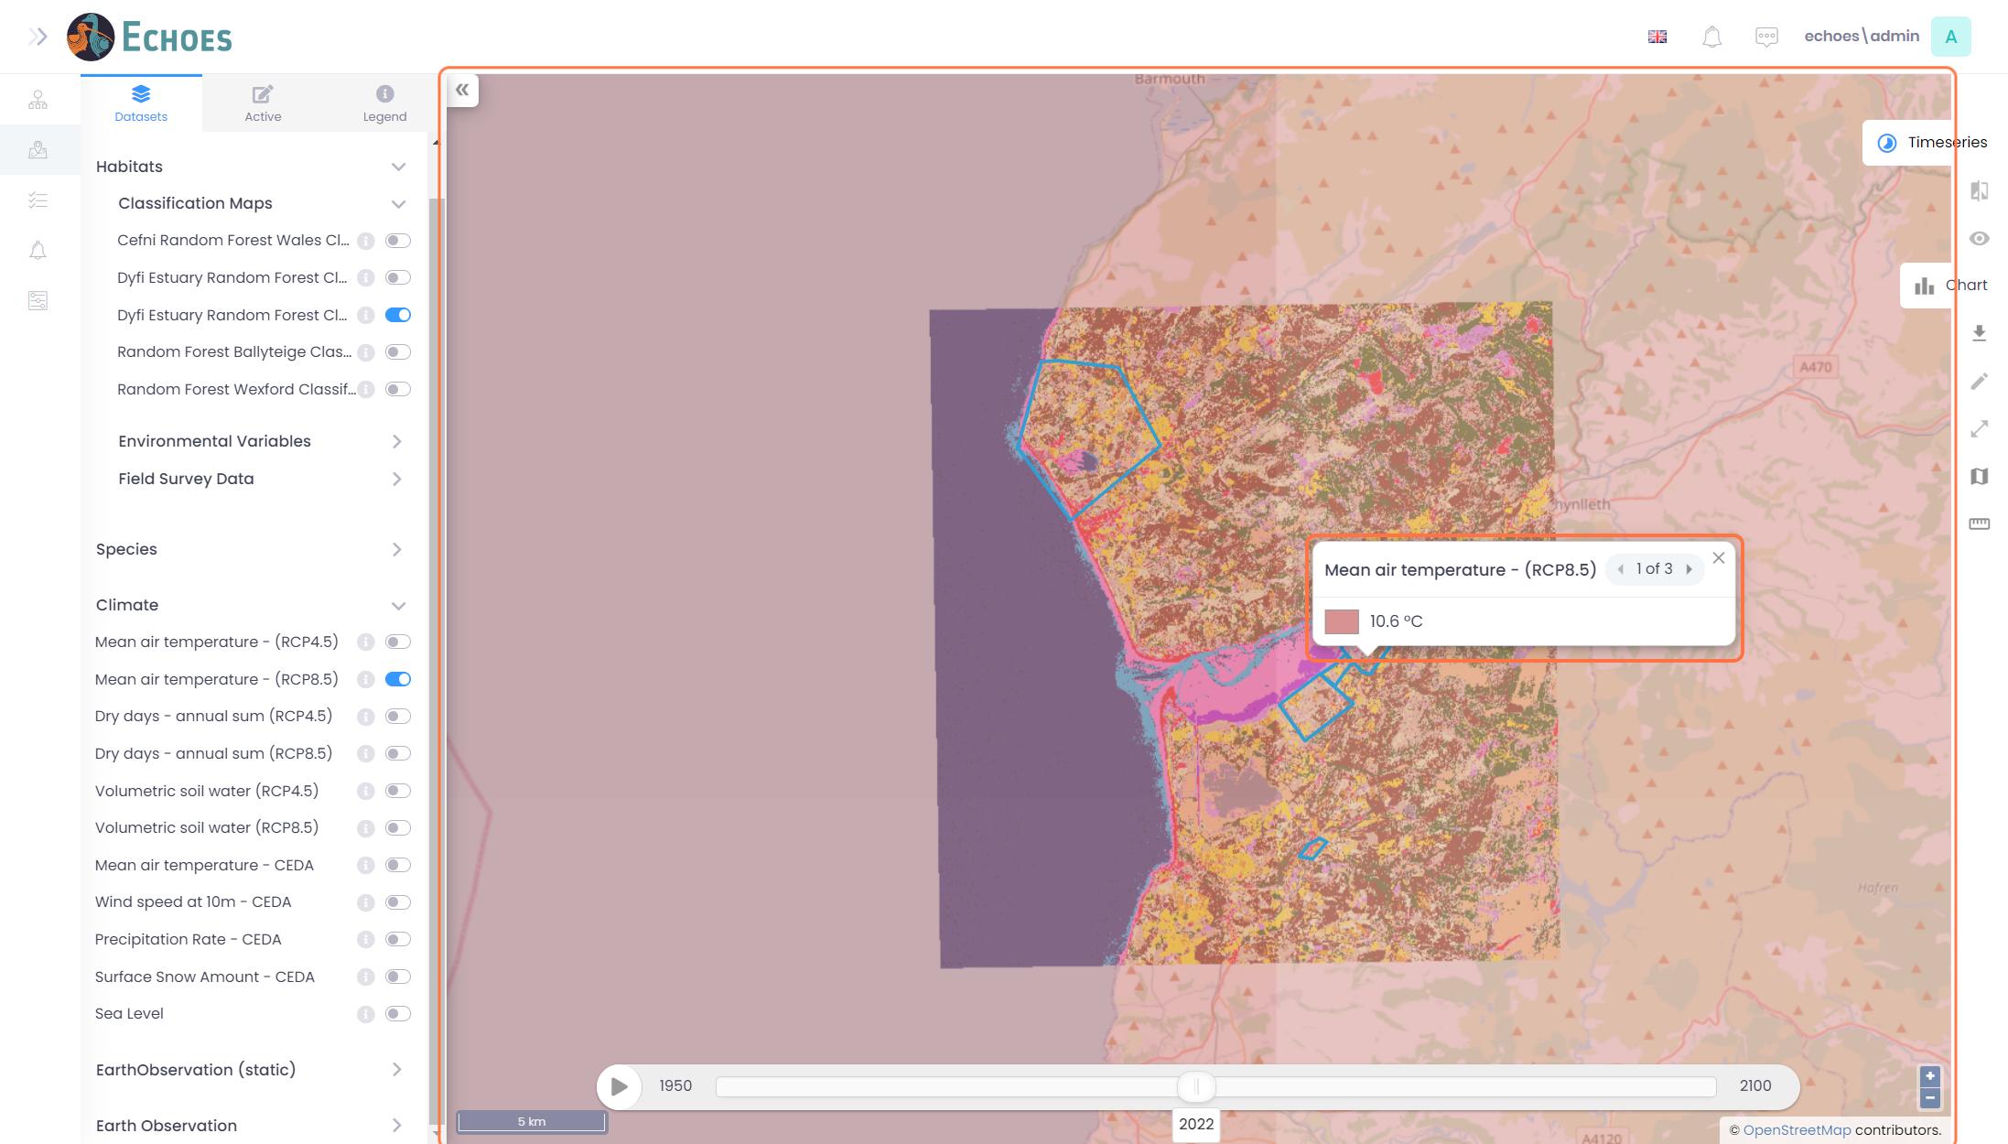

29 - Chart for Climate Data (1/3)

When you toggle on a climate layer, you have the option to view that data in a chart view. On the right-hand side of the page, you will see the 'Chart' tab sticking out to click on.

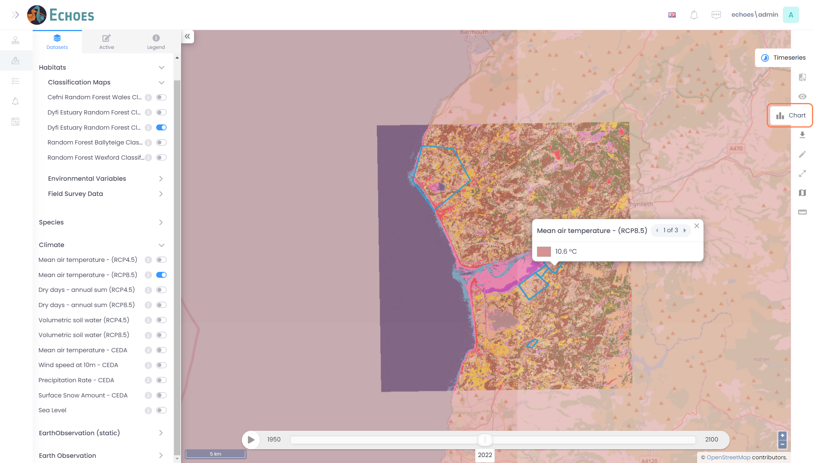

30 - Chart for Climate Data (2/3)

When you click on the chart tab, you will see the chart view pop-up for the layers you have toggled on.

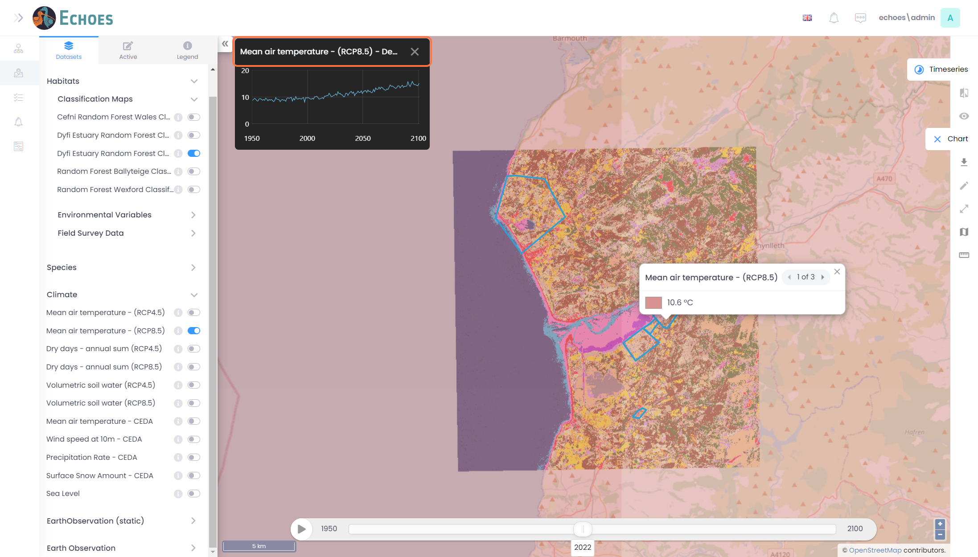

31 - Chart for Climate Data (3/3)

Hovering over the chart will show an 'Expand' icon which you can click on to expand the chart view.

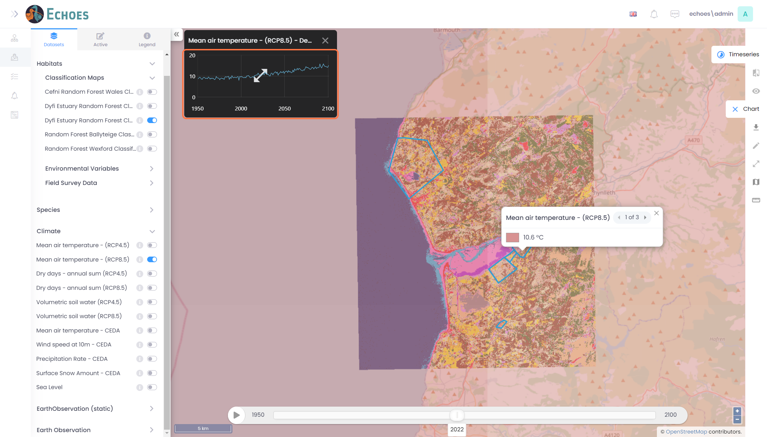

32 - Full Size Chart Table

You can now see the information available in a full chart view. Moving your mouse over the data will show you the data for that time.

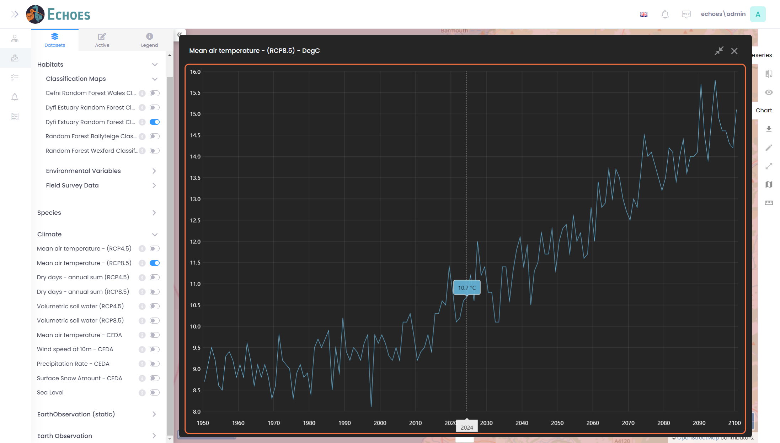

33 - Closing the Full-Size Chart Table

Clicking on the 'x' icon will minimise the full-size chart view.

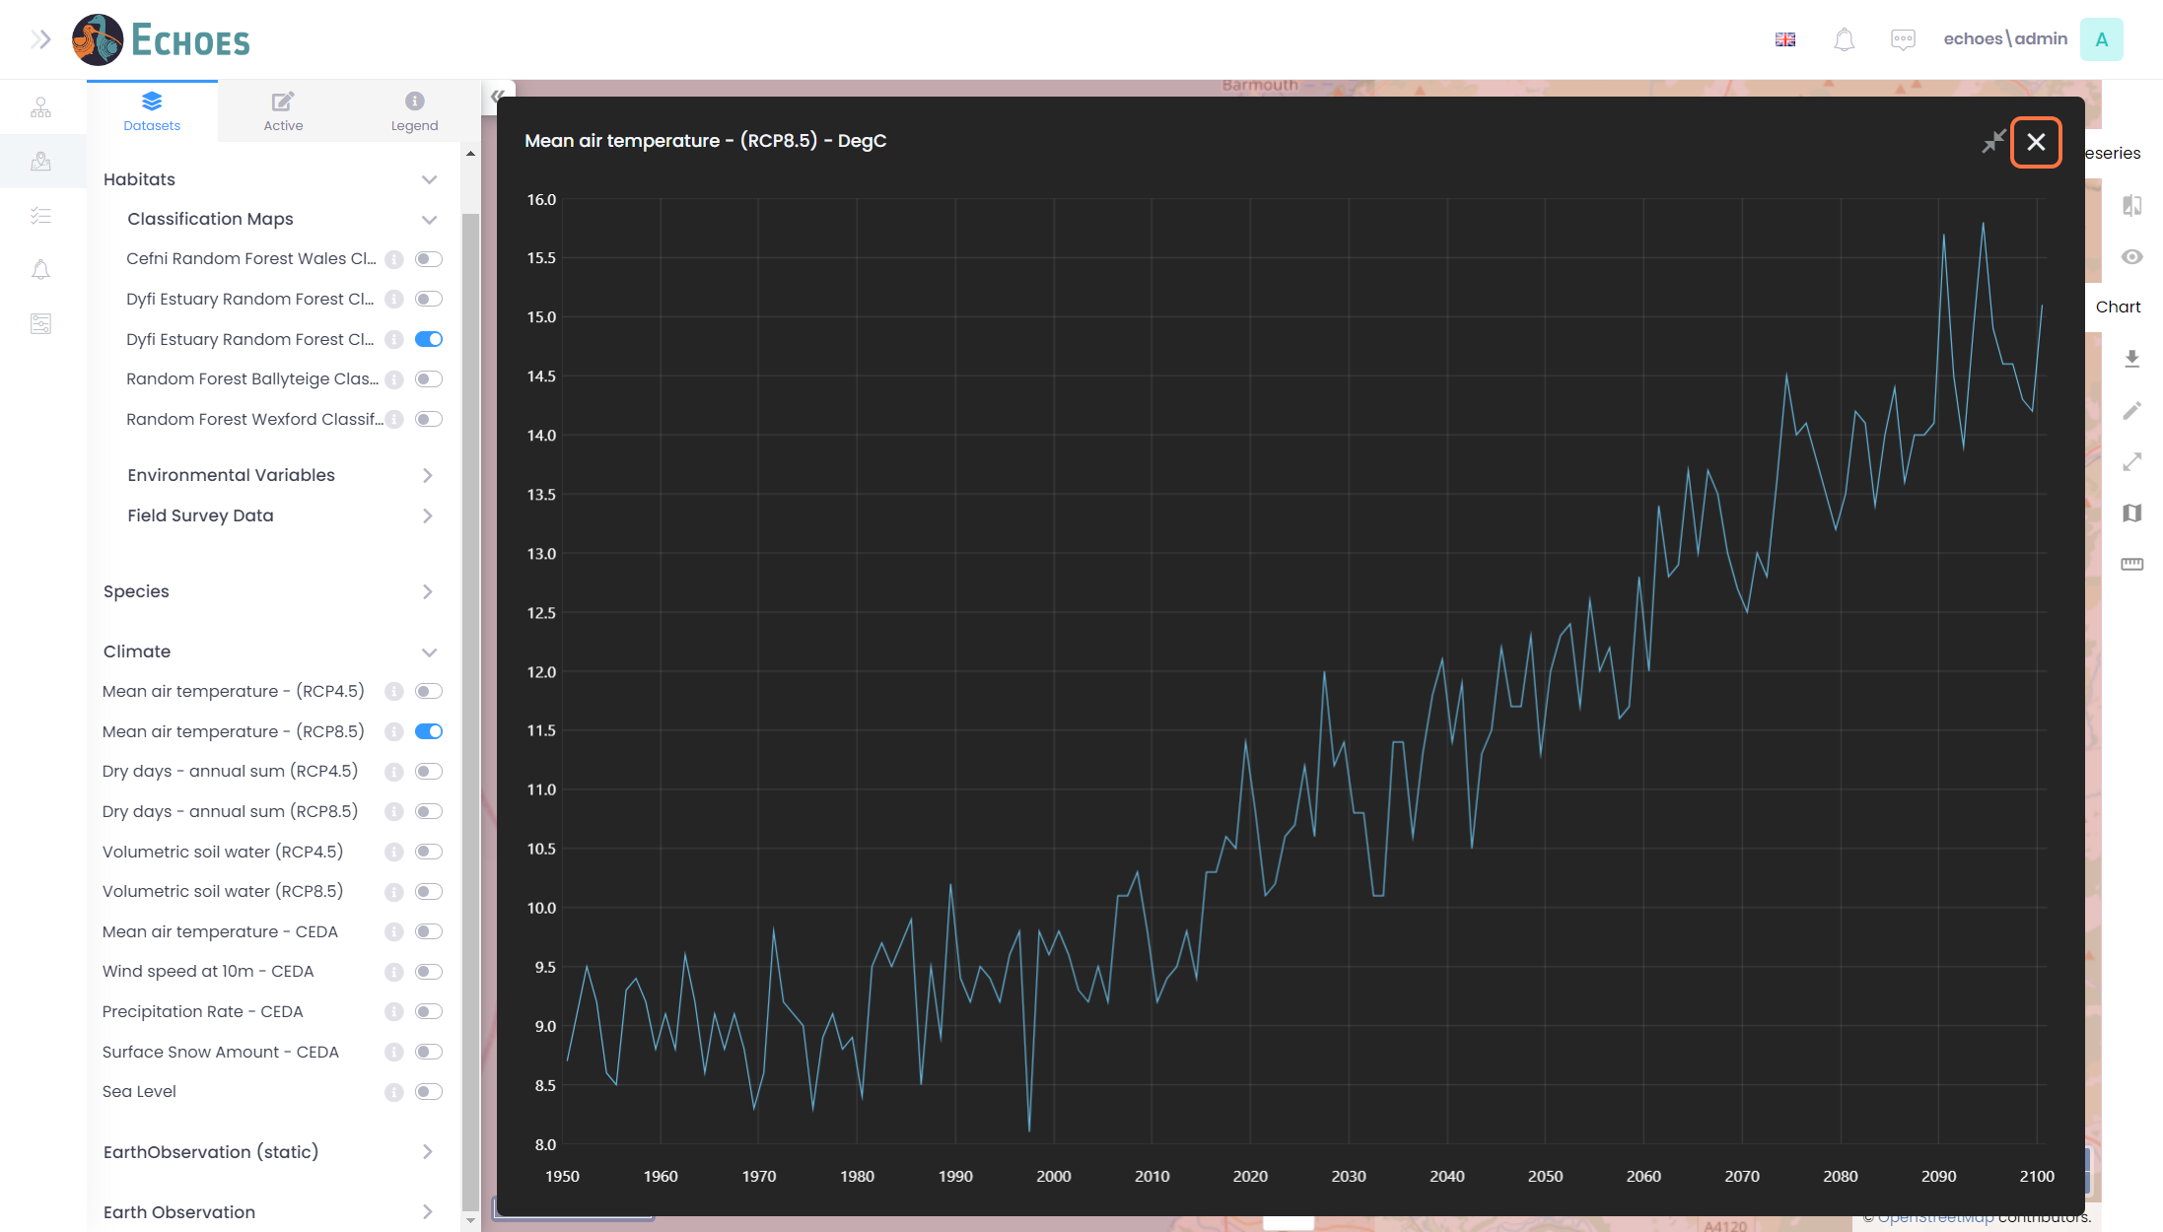

34 - Exporting the Map View

Back on the map view, you have the tool on the right-hand side called 'Export'. This will allow you to export the current view of your map and its layer information to a pdf.

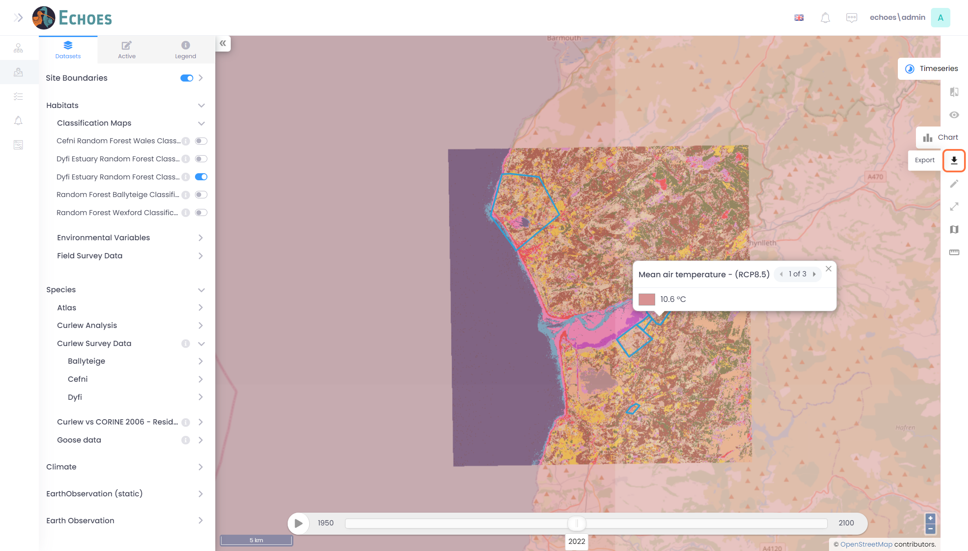

35 - Export Form (1/3)

Once you click the export button, you will see the export form popup to complete.

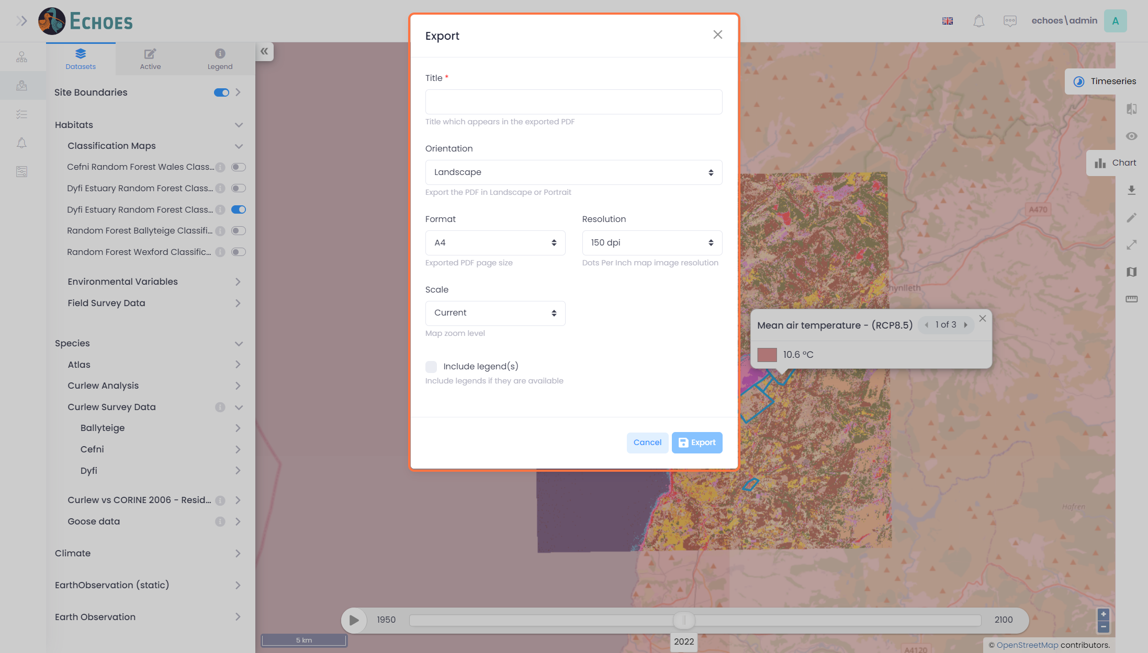

36 - Export Form (2/3)

Give your form a title and change any of the other options if you wish. The setup currently is stand so it is not necessary to change these options.

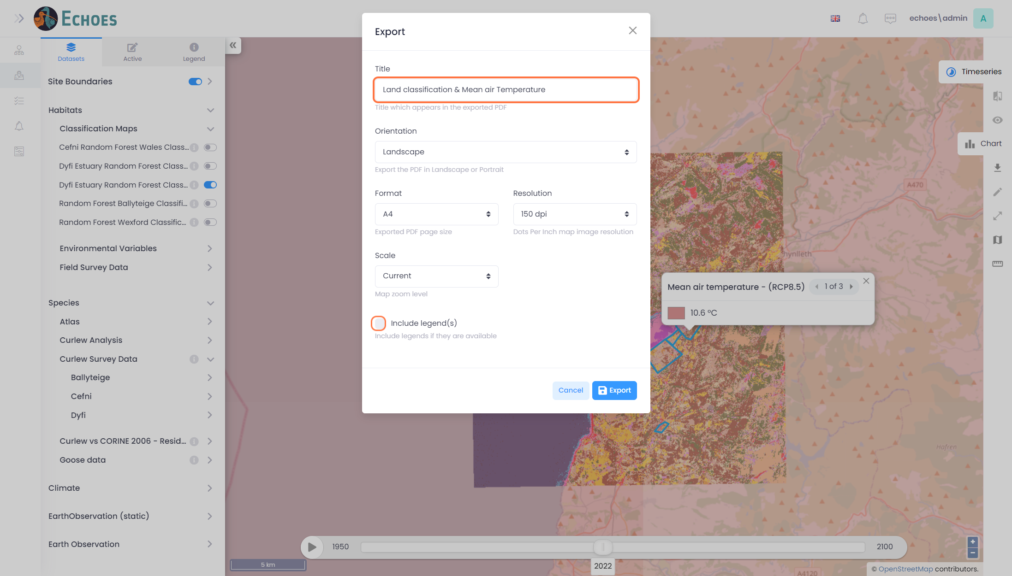

37 - Export Form (3/3)

If you wish to include the legends on the map, check 'Include legend(s)' option.

**Note:** If you have lots of different layers on, there is a chance that the legends may not appear on the map, but rather a 2nd page in the pdf.

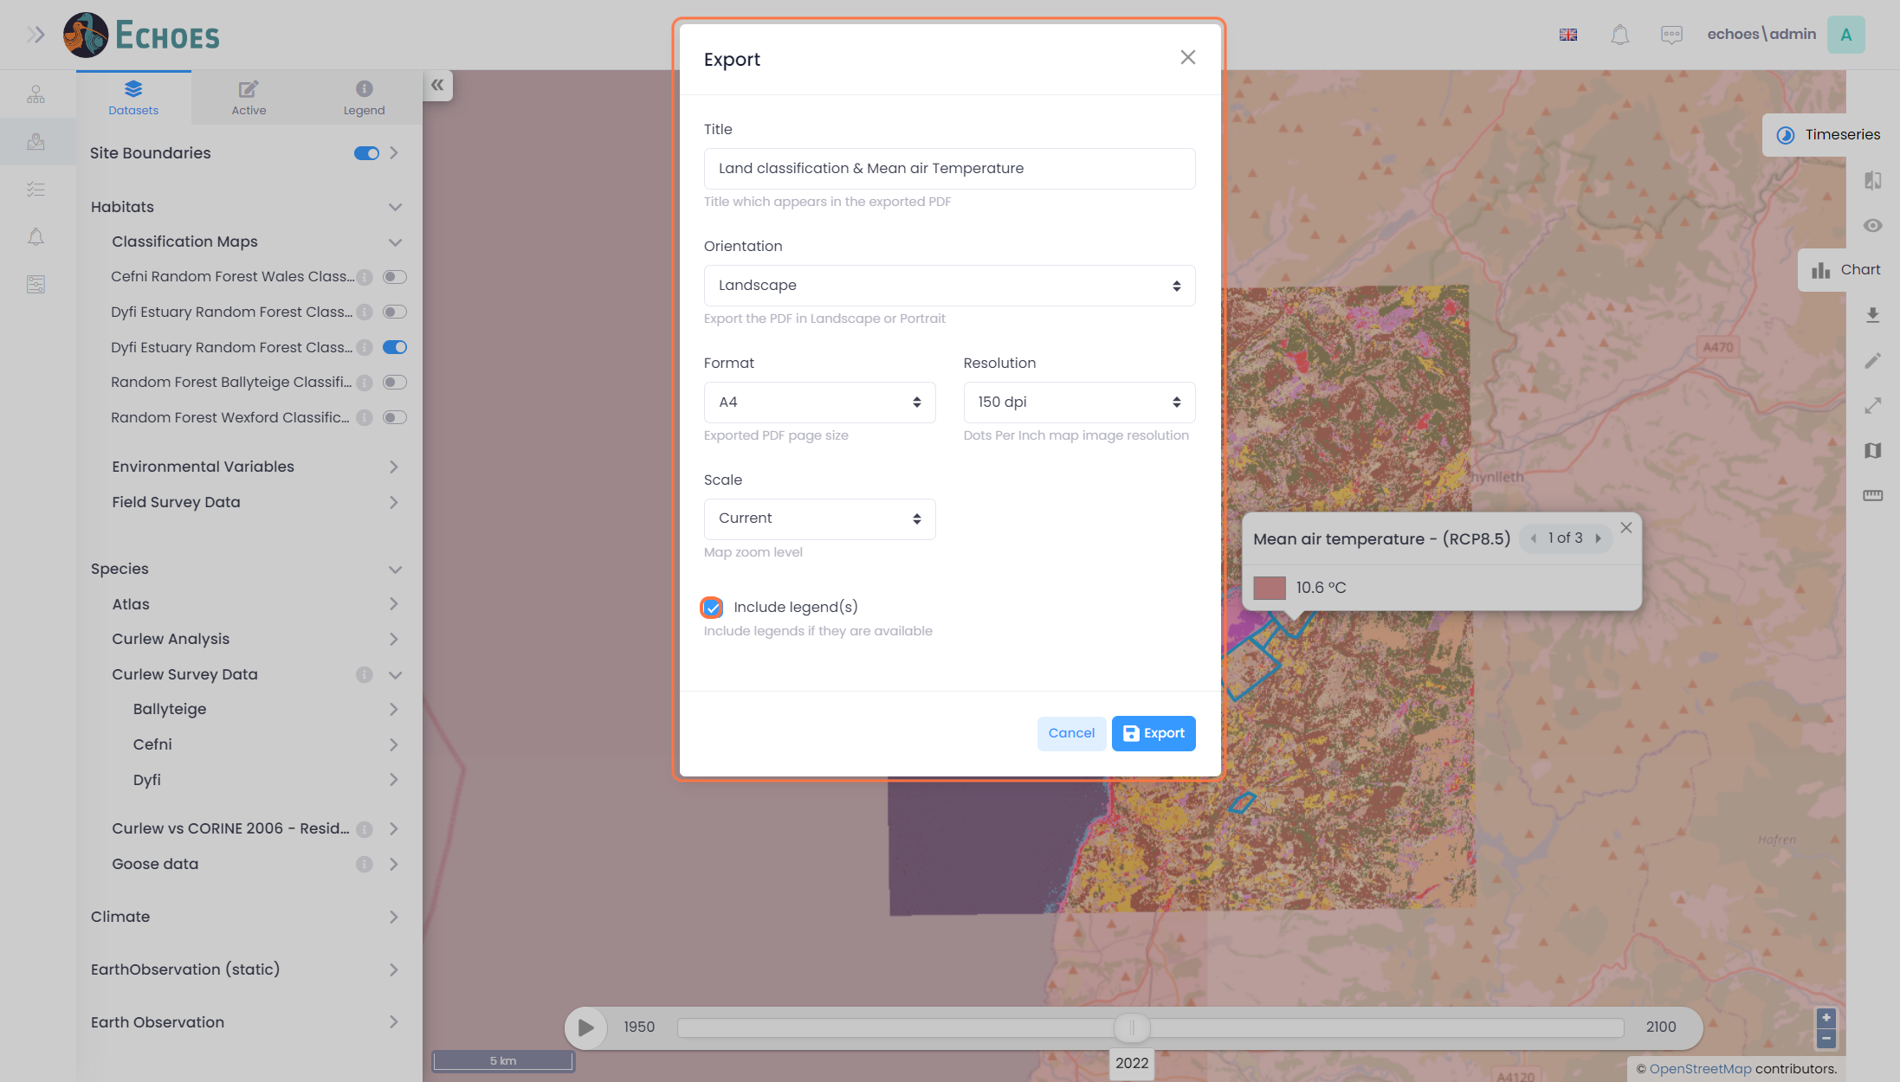

38 - Export to PDF.

Once you are happy, click the 'Export' button.

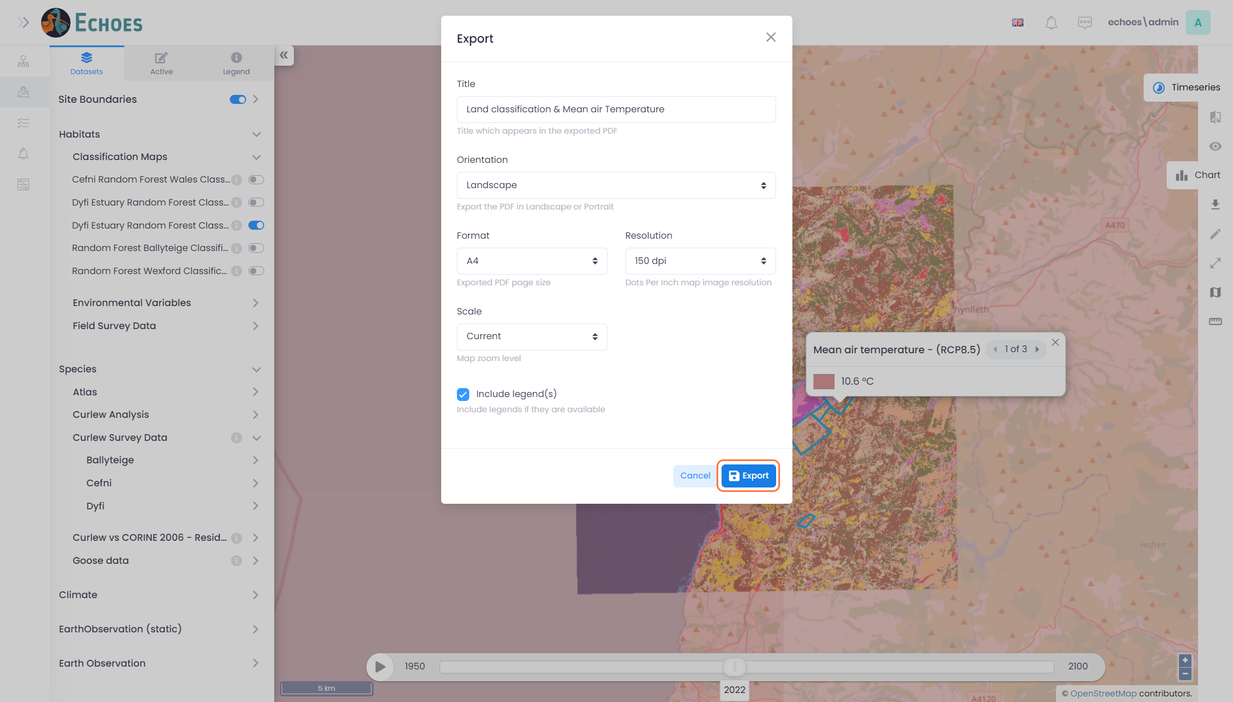

39 - Example Export

Below is an example of what your export could look like if you just give the export a name.

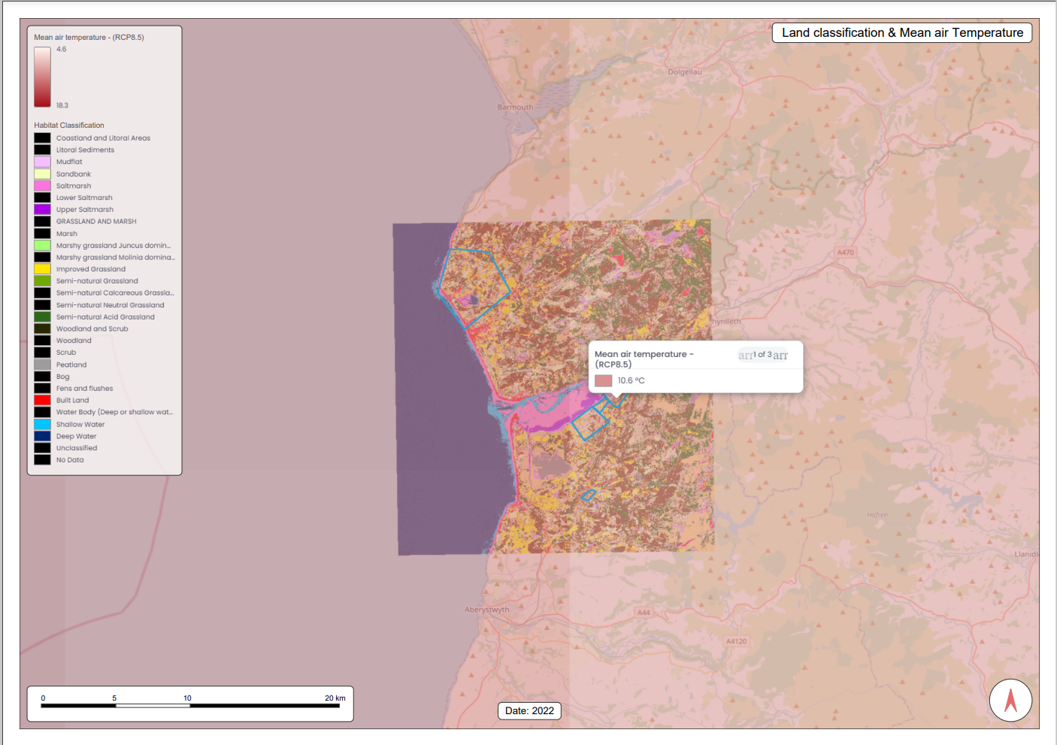

40 - Right Hand Navigation Tools

On the right hand side, you will see some more navigation tools available.

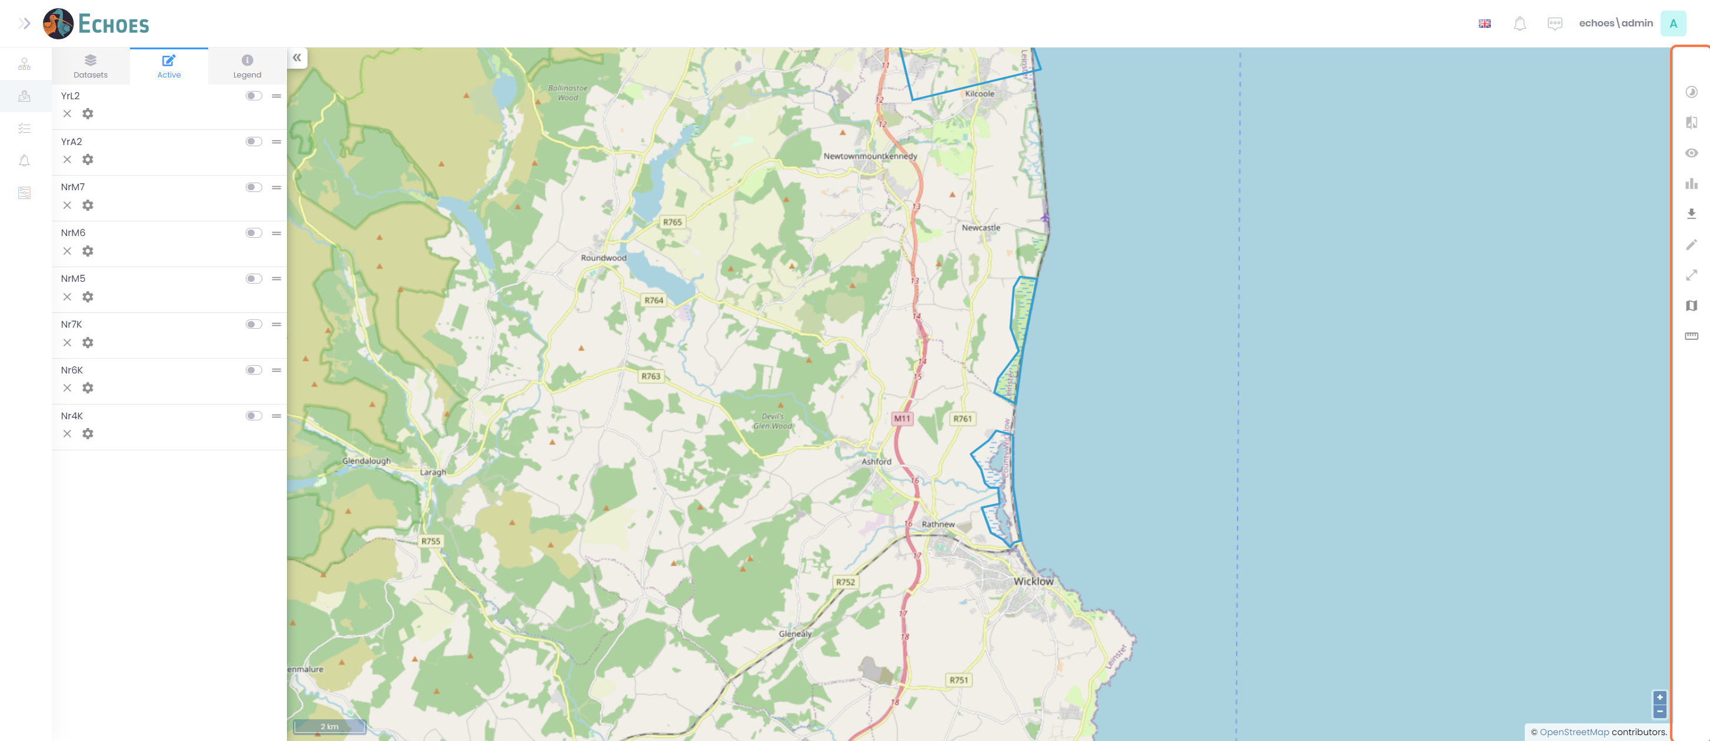

41 - Base Map (1/3)

You have the Base map tool icon.

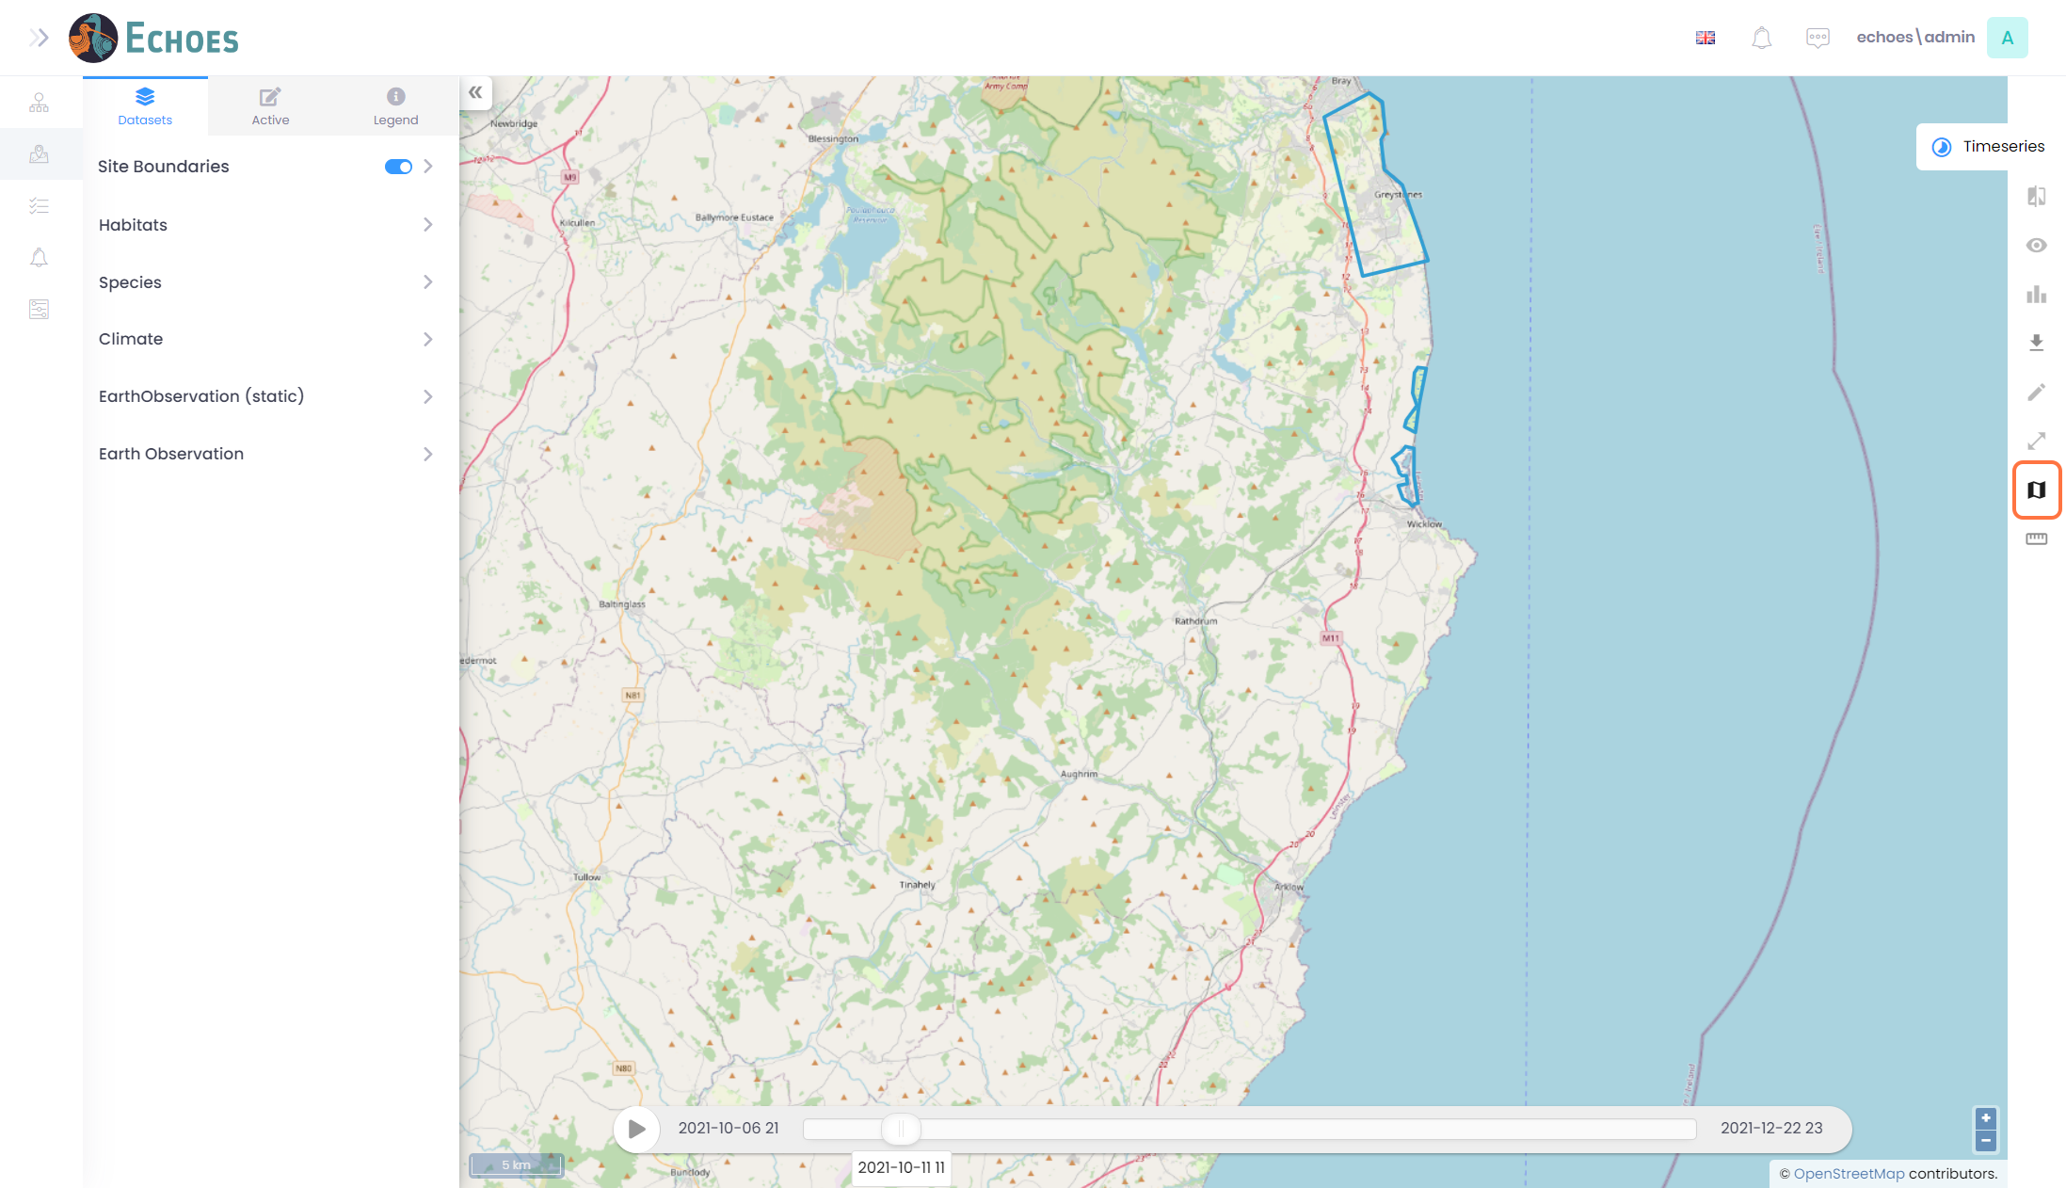

42 - Base Map (2/3)

Here you can toggle between the Open Street Map base map.

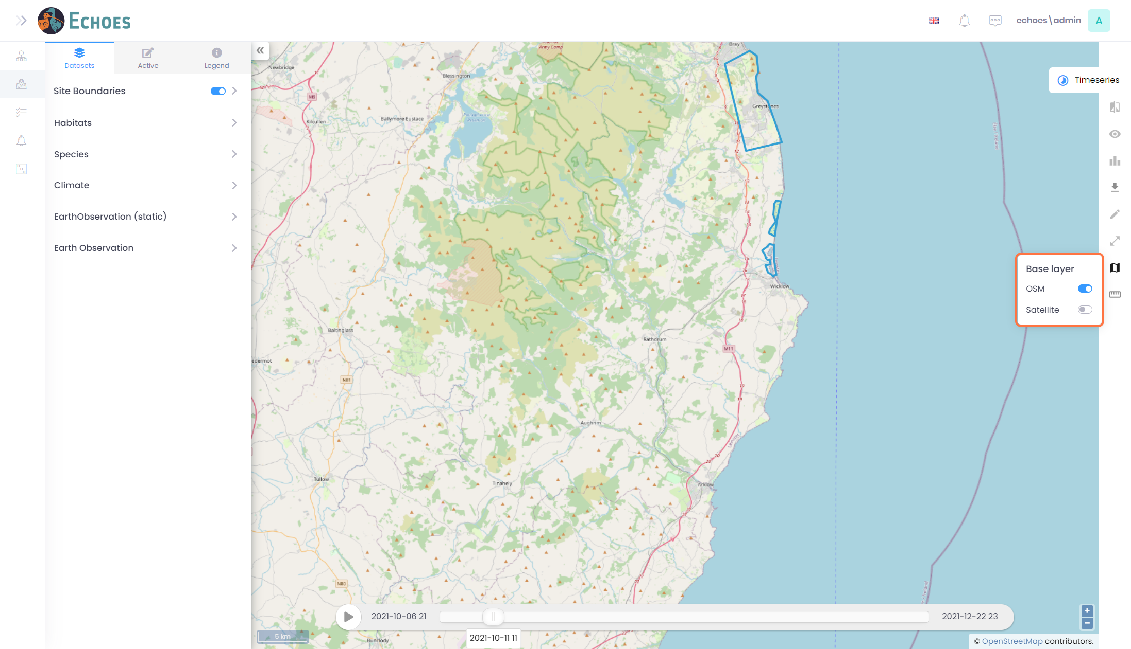

43 - Base Map (3/3)

And toggle the Satellite base map on.

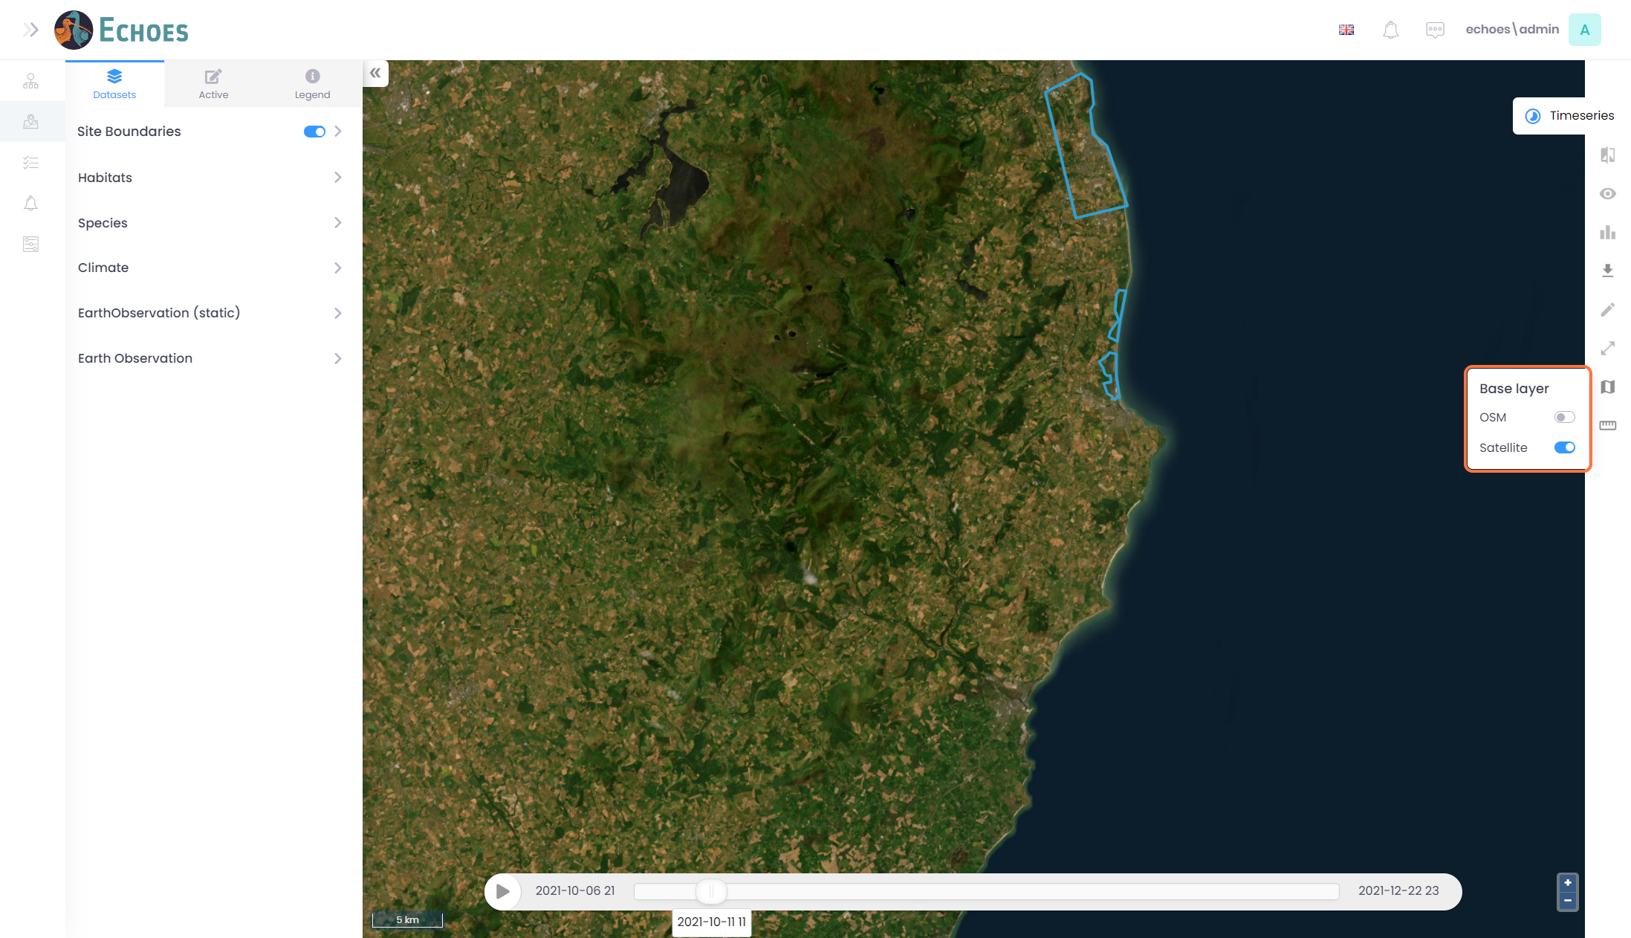

44 - Measurement Tool (1/2)

Here you have to Measurement tool icon.

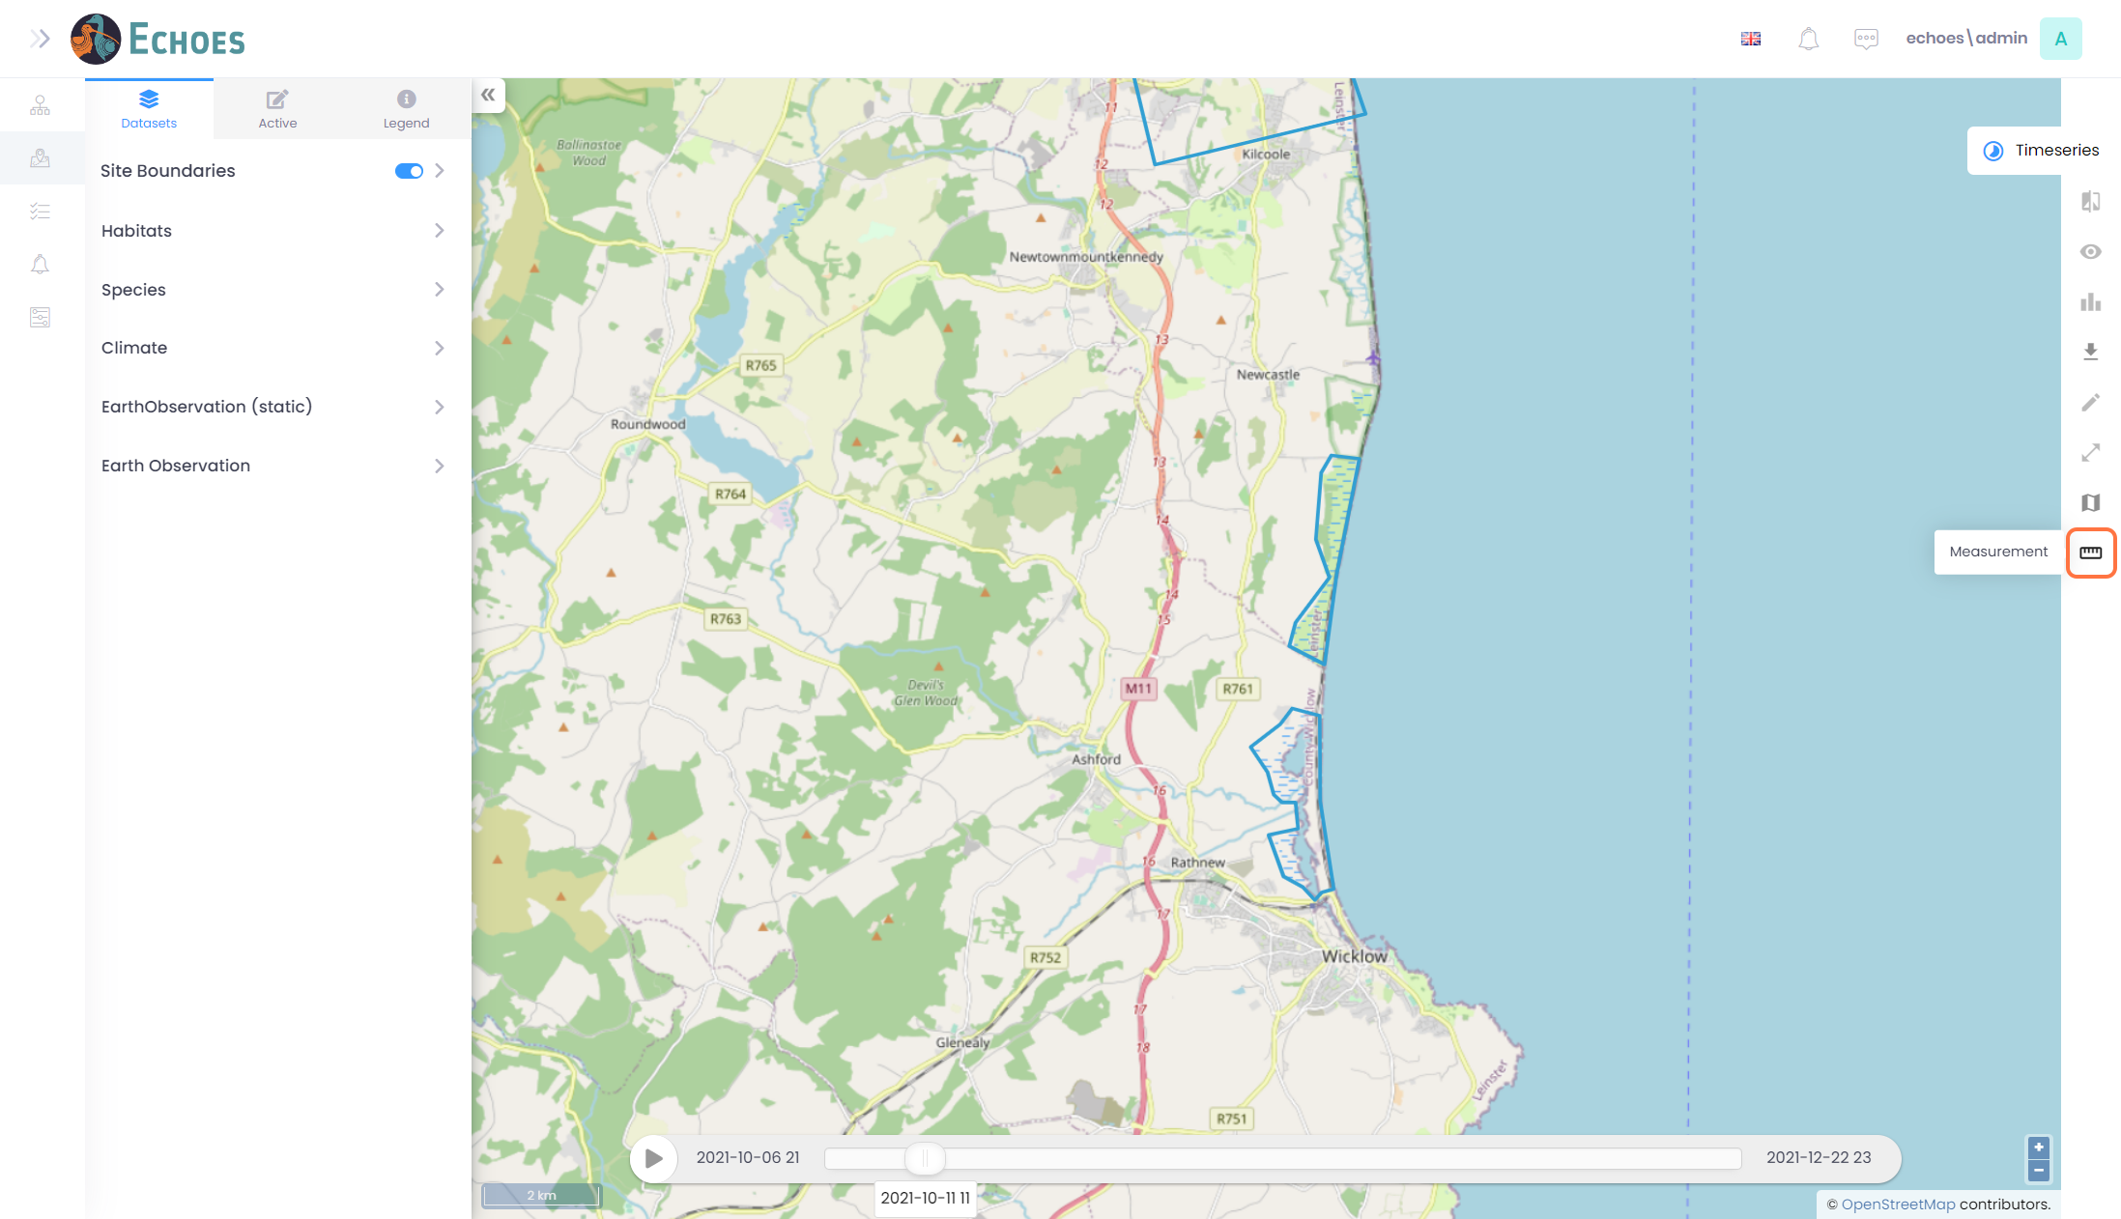

45 - Measuring Tool (2/2)

Here you have the option of 3 different measuring tools to choose from.

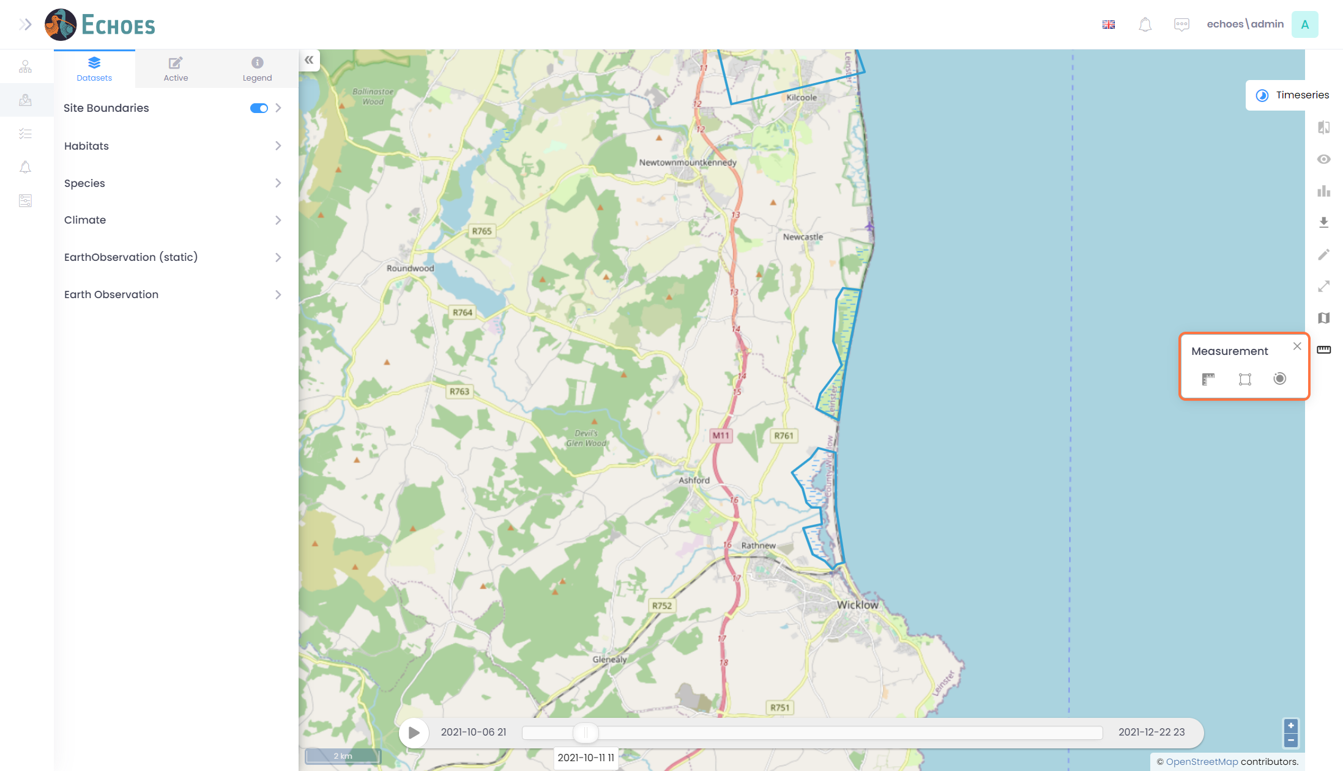

46 - Measure Line Tool (1/3)

The 1st tool is the measure line tool.

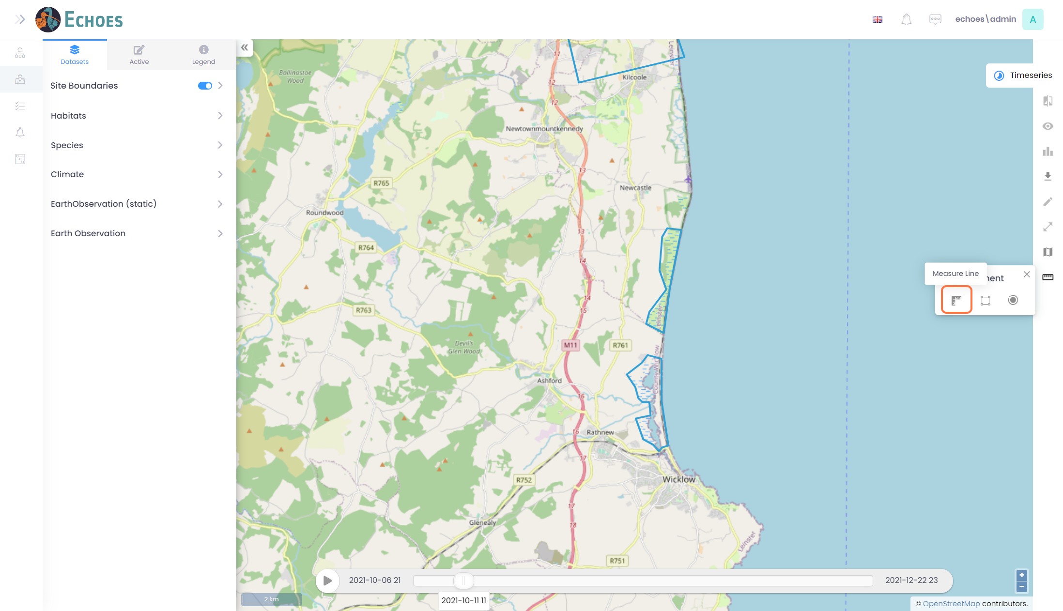

47 - Measure Line Tool (2/3)

Clicking on a point where you want to measure from, then moving your mouse to create a line. You can draw straight lines, clicking again to move in a straight line to another direction.

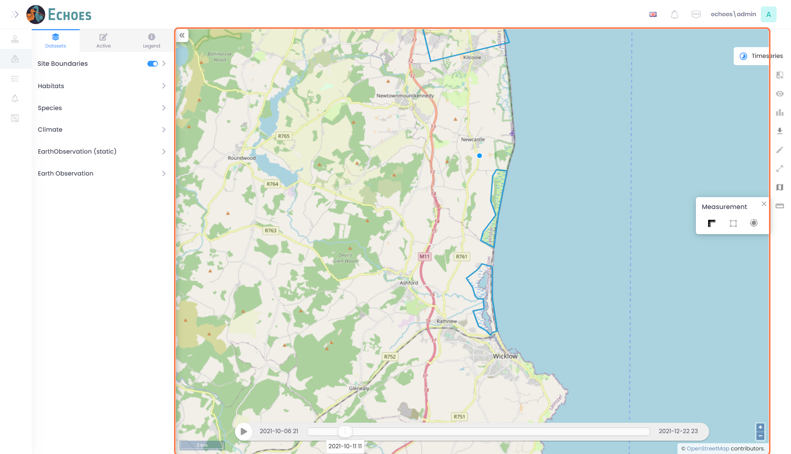

48 - Measure Line Tool (3/3)

Once you have finished marking out your line, click twice in the same point to complete and calculate your line. You will see the length on top of your line, as well as in the Measurements tool section.

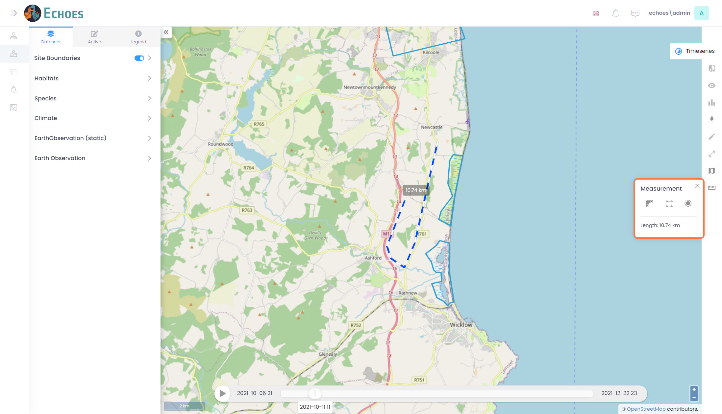

49 - Measure Area Tool (1/3)

Next there is a measure area tool. This will calculate the area of a drawn shape.

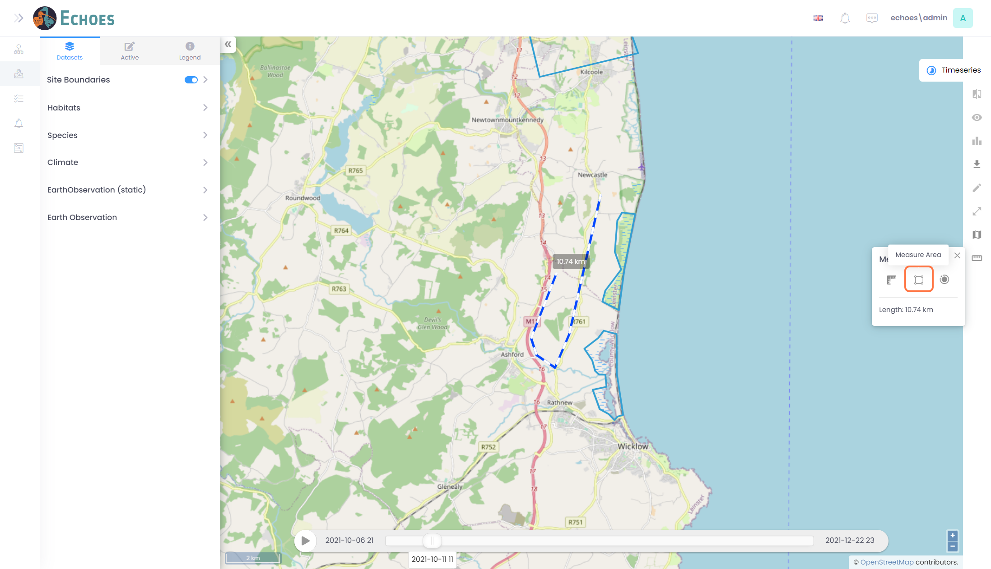

50 - Measure Area Tool (2/3)

Click the map to start the tool, clicking again to draw another line. The tool will calculate in real time your area by filling in the difference with a straight line.

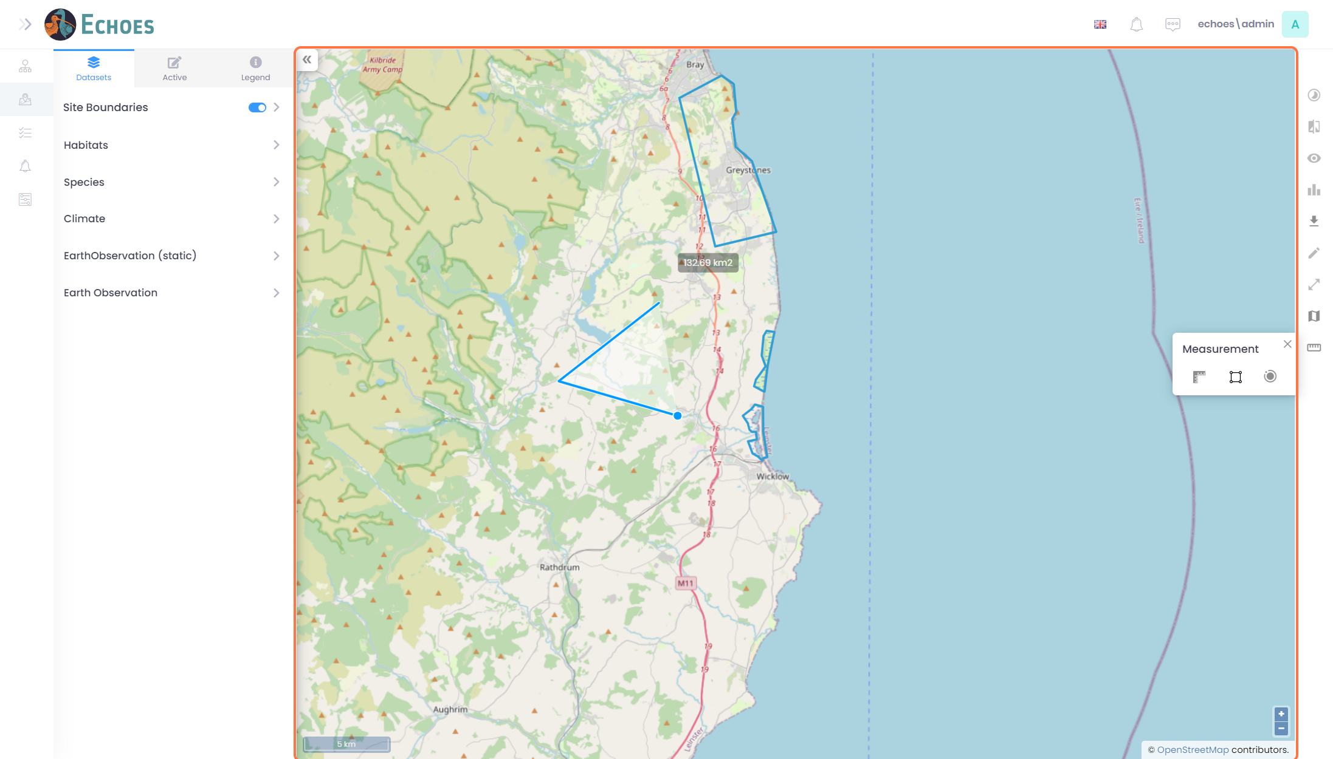

51 - Measure Area Tool (3/3)

Once you have finished marking out your line, click twice in the same point to complete and calculate your area. You will see the area on top of your shape, as well as in the Measurements tool section.

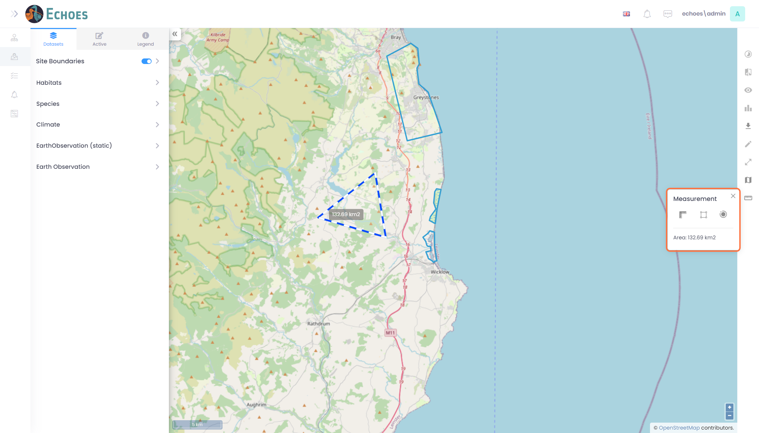

52 - Radius Tool (1/3)

Last you have the radius tool. This will calculate the area of a given radius you draw.

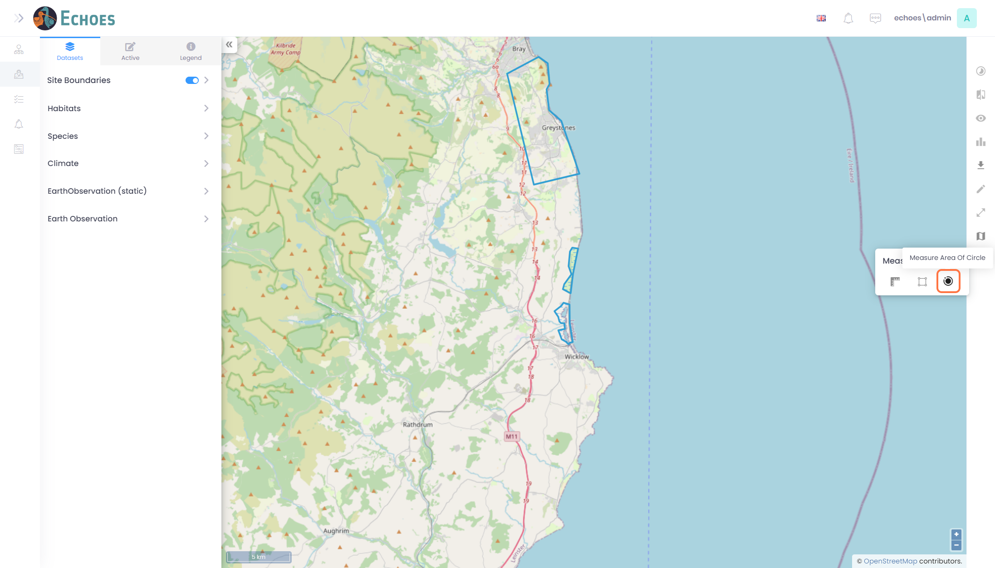

53 - Radius Tool (2/3)

Click the map to start the tool. Move your mouse to increase or decrease the radius of your circle. The tool will calculate in real time your area as you move your mouse.

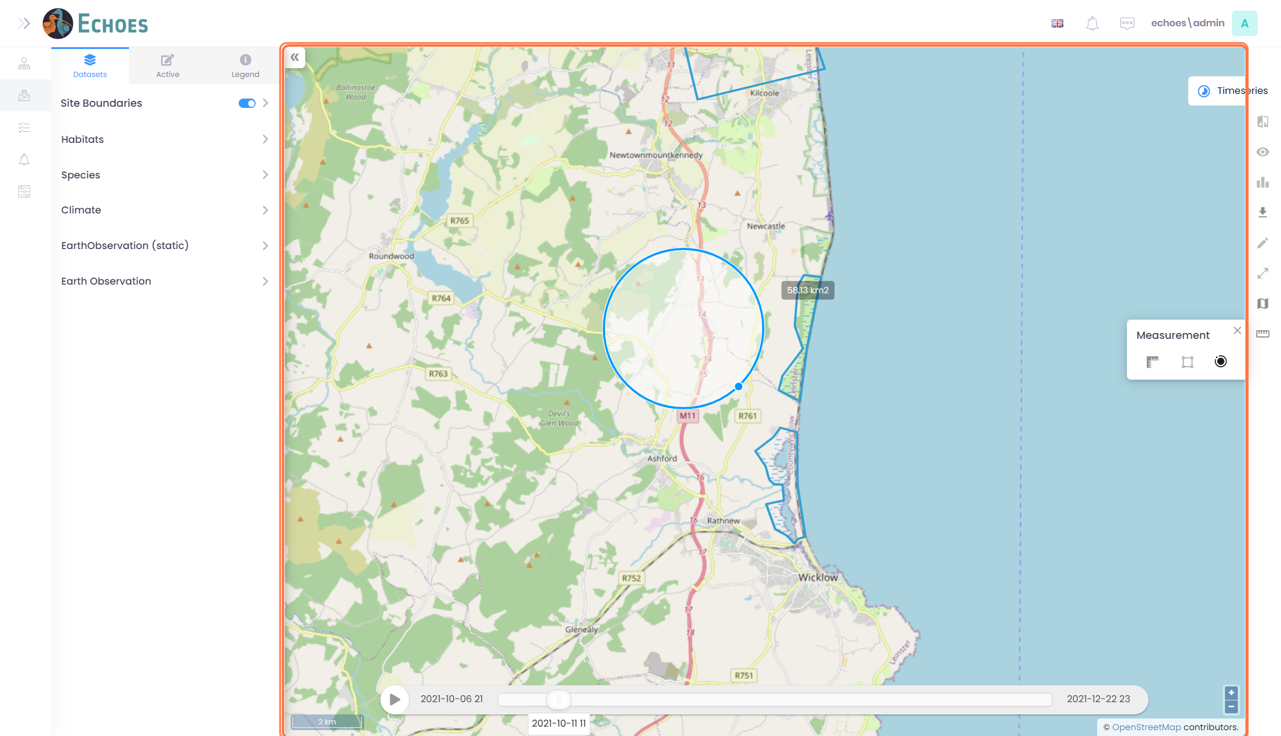

54 - Radius Tool (3/3)

Once you have finished marking out your circle, click again to complete and calculate your area. You will see the area on top of your shape, as well as in the Measurements tool section.

